Document Title: Data Management Overview
Document Number: PTUC SOP077
Staff involved in development: Job titles only | Senior R&D Manager, R&D Operational Manager, Clinical Project Managers, Senior Clinical Trial Data Manager
Document owner: | Senior R&D Manager
Directorate: | Research and Development
Department: | Research and Development
For use by: | NHS Staff Trust-Wide
Review due: | July 2025
THIS IS A CONTROLLED DOCUMENT
Whilst this document may be printed, the electronic version maintained on the Trust’s Intranet is the controlled copy. Any printed copies of this document are not controlled. ©Royal
Papworth Hospital NHS Foundation Trust. Not to be reproduced without written permission.

Summary of Amendments
Version No: | Modification:
4.0 | Amendments throughout

Key Points of this Document

- This document sets out the procedures to be followed by all Papworth Staff who are involved in the management of research data, to be managed by Papworth Trials Unit Collaboration, or sponsored by Royal Papworth Hospital NHS Foundation Trust.
- It provides guidance on the steps involved in data management to ensure compliance with the Trust’s policies.

Other documents referenced in this SOP
In Appendix A the flow chart shows when these documents are used.

- SOP078 – Data Management Plan • GD016 - Data Management Plan
- FRM046 - Data Management Plan
- FRM047 – Variable List (includes guidance)
- FRM055 – eSAE CRF Design Checklist
- GD007 – Clinical Data Management Study Setup
- GD008 – User Acceptance Testing
- FRM049 - User Acceptance Testing
- FRM018 Database Testing and Acceptance Form
- FRM051 Registration Form
- GD014 – Clinical Data Management Validation
- FRM048 – Data Validation Specification (includes guidance)
- FRM071 - Importing data into OpenClinica
- GD009 – User Access
- FRM052 - User Access
- GD010 – User Training
- GD011 - OpenClinica User Guide
- FRM037 - Design Changes
- GD012 – Data Cleaning
- GD017 – Randomisation procedure and unlocking
- FRM053 - Interim Lock Approval
- FRM017 Database Lock and Close Down Form
- FRM019 - Permission to unlock a Hard Lock Database
- FRM039 OpenClinica Data Amendments
- GD023 – eForms system for study documents
- GD013 - Database Locking
- GD025 – Data Sharing

1 Purpose and Contents
- This document defines the Trust’s procedures for data management to perform a research study that is either managed by Papworth Trials Unit Collaboration (PTUC), or sponsored by Papworth Hospital NHS Foundation Trust.
- Data management is important in every type of study and trial. Information gathered for a study, must meet the requirement of the protocol, and be analysable to answer the study hypothesis. At extremes, poor data management can lead to patients being unnecessarily put at risk.
  - Good Clinical Practice (GCP) states “All clinical information shall be recorded, handled and stored in such a way that it can be accurately reported, interpreted and verified, while the confidentiality of records of the trial subjects remains protected.” 2005/28/EC article 5.

  - Data integrity is the maintenance, and the assurance of the accuracy and consistency, of data throughout the study (from the patient to analysis), and involves every person involved in a trial.
- This overview covers the steps required to facilitate the data management from start to finish of a study.
- Appendix A shows the Data Management Overview in flowchart form.
- Appendix B is a check list for the steps in the design and set up stages.
- This document identifies the steps necessary to validate the data management process, which must be undertaken prior to its use.

2 Roles & Responsibilities
- This Policy applies to all personnel that are conducting research at the Trust. It is the responsibility of the department’s personnel to ensure they are familiar with and adhere to all current SOPs, and have signed the relevant log in their training record.
- The Chief Investigator (CI) should assign the following roles, which should be documented in the Data Management Plan (DMP, SOP078). The CI can assign themselves for these roles, and these roles can be assigned to the same person.
  - Data Management Lead (DML), who will either be a member of the PTUC Data Management team or the nominated data manager for other studies, based on table 1; they are responsible for making sure this SOP is followed.

  - Clinical Data Lead (CDL), who will work closely with Data Management Lead and the Project Manager (PM) to assist when clinical input is required, they also ensure this SOP is followed. This should be the Investigator or an appropriately qualified member of the research team.
- The Chief Investigator is responsible for the final sign off prior to the database going live.

3 Policy
a. This SOP is mandatory and, as per the Trust’s Information Governance and Records Management framework, non-compliance which may result in disciplinary procedures.

4 Procedure

4.1 Requirements
a. For Papworth sponsored studies, table 1 shows when data management support is required.
Study Type | Single/Multi Centre | Data  Management | OpenClinica
CTIMP | Both | Required | Required
All | Multi Centre | Required | Required
Interventional | Single | Required | Optional
Observational | Single | Optional | Optional

4.2 Design and Set Up

4.2.1 Precursors
- The protocol should have been reviewed specifically from a data management perspective as part of the review for sponsorship; this should include the Data Management Lead.
- An electronic data repository (database) should be selected; table 1 shows if OpenClinica is required. (OpenClinica is the current PTUC preferred data repository, but if this is changed in future, any comments in this SOP regarding OpenClinica will apply to the new repository.)
- The preferred method of data capture should be agreed: direct entry into electronic case report forms (eCRFs), data imported into OpenClinica or paper case report forms (pCRFs). Data capture methods can be combined if required.
- A Data Management Plan (DMP) should be started, SOP078 – Data Management Plan covers this in detail. FRM046 DMP Prior to build start should be completed prior to the start of the build and FRM046 DMP Prior to going live should be completed prior to study going live. The DMP is a living document throughout the study, and is only finalised when the study is closed. In studies involving a medicinal product the DMP should be reviewed as part of the risk assessment process. The following should/must be included in the DMP.
  - Electronic data repository (database)
  - Clinical Data Liaison
  - Data Capture method
  - Back Up procedures for the study
  - Data Validation Plan

4.2.2 Design
a. Variable List
- A variable list should be completed by the CDL, detailing each data point to be collected and its metadata, FRM047.
- The variable list must be reviewed and accepted by the data management lead. b. eSAE CRF
1. Serious Adverse Events (SAEs) should be reported electronically using the eCRF. Depending on the type of study (CTIMP, Device or procedure etc) the fields included will change. FRM055 eSAE CRF Design Checklist records which fields and CRFs have been selected. The build stage of the CRFs can start without this, but it should be completed before the end of the stage.

4.2.3 Build
a. The steps involved in the build phase, are dependent on the electronic data repository and the data capture method chosen for the study, but usually would be as follows:
- The electronic data repository/eCRFs will be built using the completed variable list

- Additional programming will be added where applicable.

- These are reviewed by the CPM, CDL and the DML, adjusting until ready for testing. The process in 4.2.3a is detailed in the Clinical Data Management Study Setup guidance document (GD007).

4.2.4 Testing
- For CTIMPs, non-CE / non-UKCA marked device trials and multi-centre studies a full User Acceptance Test (UAT) process must be followed. The UAT guidance document (GD008) details this. The scripts produced will be given to multiple members of the team to test the CRFs and electronic data repository functionality.
- For non CTIMP single-site studies this process can be fast tracked on approval by the Trial/Project Manager, this must be detailed in the DMP, or trial documentation. The UAT guidance document also details the fast track UAT.

4.2.5 Statistician review
a. During the build the Data Management lead should continuously liaise with the study statistician to ensure all of the necessary variables have been included to complete the analysis. The statistician can confirm they have reviewed the variables and CRFs via E-Mail (or by using the designated tab on FRM047). The statistician should review the variables during the completion of the Variable List (FRM047) and prior to going live.

4.2.6 Paper CRFs (pCRFs)
a. If pCRFs are to be used in the study:
- The pCRF need to be tested for layout and usability, and confirming that the order of the data matches the eCRFs before the final rounds UAT.
- A standard format is available, but these can be made in Excel, Word, Formic or similar. The pCRFs should be approved by the PI using FRM018 Database Testing and Acceptance Form

4.2.7 Further guidance
a. Clinical Data Management Study Set Up guidance document (GD007) gives further information for each of the sections above.

4.3 Validation
- Validation is needed in the data management process; the validation guidance document (GD014) covers this in detail. When discussing validation in Clinical Trials, be aware that it is usually used to describe different aspects of data management.
  - Computer System Validation
  - Build Validation
  - Data Validation
  - Source Data Verification
- Within the Data Management Plan (SOP078) there is a Data Validation Plan which contains details including the whether there is an assigned Study Data Manager, the type of UAT required and whether a Data Validation Specification form (FRM048) needs to be completed (this is a requirement for Papworth sponsored CTIMPs and non-CE/UKCA marked device trials)

The Data Validation Specification form (FRM048) includes details of on-entry data validation checks programmed into the eCRF (including OpenClinica rules if applicable) and validation checks done on a batch or continual validation basis.

4.4 Live phase

4.4.1 Making the System Live
- Once the Database Acceptance form (FRM018) has been signed by the CI, the system can be made live. The system is migrated from a ‘test’ environment to a ‘live’ environment (including purging any test data) and appropriate permissions are granted and test permissions are revoked.
- It is recommended that the UAT is run again on the ‘live’ site to confirm the validation of the design.
- For some systems, there may be further requirements, such as the implementation of a back-up and maintenance schedule and the generation of documentation. These processes should be documented in the DMP.
- User Access should be determined, dependant on user role, and the ability of the data repository to handle different user types, the User Access guidance document (GD009) details this.

4.4.2 Post-Live Design Amendments
- Occasionally, even with due diligence, either the protocol or the CRFs need amending after the study has gone live, leading to post-live design changes. The detailed review of the CRF at the start of the study should keep this to a minimum.
- Care should be taken to ensure that any changes are applied to both paper CRFs and databases when applicable.
- Once identified and approved, design revisions should be documented on the Design Changes form (FRM037) and be approved by the Trial/Project Manager.
- Care must be taken to prevent corruption of existing data or invalidating source data verification for any CRFs. GD012 Data Cleaning provides further guidance on this.
- Documentation must be updated in line with the relevant version control guidance. For CRF versions, Data Management uses increments of the decimal (1.0 > 1.1) for minor tweaks to the CRF version (typos, errors) and increments of whole numbers (1.0 > 2.0) for large changes including protocol amendments. In some cases, a change is only required to the pCRF or only the eCRF, therefore it is not unusual for the versioning of pCRFs and eCRFs to differ.
- Further testing will be required to ensure any amendments are implemented correctly. Depending on the complexity of the change the UAT tests may be run again; however, it is acceptable for the trial team to identify the affected CRFs or visits and only test a shortened version of the UAT.

4.5 Data entry and Cleaning Phase

4.5.1 Training and User Guides
- All users of the electronic data repository should be trained in the relevant modules, including data queries, the level of training will be dependent on the complexity of the study and the experience of the user, and this is detailed in the User Training guidance document (GD010).
- At minimum generic data entry guides (GD011) should be provided to all users. Study specific “guide sheets” or full guides could be provided, again dependent on the complexity of the study.

4.5.2 Data Queries
a. Data queries can be generated by monitors, by inbuilt validation, edit checks, and the data management team. This is covered in the Cleaning guidance document (GD012).

4.5.3 Non-standard Data Entry
- Data entry changes that require the data management team (e.g. deleting data entry errors), must be documented in using FRM039 OpenClinica Data Amendments, and approved by the Trial/Project Manager.
- Data can be imported directly into OpenClinica following the procedure and guidance set out in FRM071 - Importing data into OpenClinica.

4.5.4 Lock preparation
- The preparation for a database lock depends on the type of lock that is being performed.
The Locking guidance document (GD013) covers this in more detail.
  - An Interim lock is a process that takes a “snapshot” of a database at a particular point in time while the study is still in progress. This is only performed if specified in the protocol.

  - A Final lock (also known as a “hard lock”) is a process that removes access to the database to ensure no further changes to data can be made.

- The following are steps that are part of lock preparation. The steps required for a final lock, and an interim lock, will be documented in the DMP.
  - CRF completion review
  - Data query review
  - AEC review
  - SDV review
  - SAE reconciliation (if appropriate)

4.5.5 Data Monitoring Committee (DMC)/Interim Lock
- If an interim lock is required, the interim lock form (FRM053) must be completed, specifying what data, subjects and/or CRFs, are to be included. These will be cleaned according to the DMP and locked. The Locking guidance document (GD013) covers this in more detail.
- For a DMC meeting, an interim lock can be chosen, or a snapshot of the data can be used.
- Data transfers must follow what is specified in the DMP, and must be via a secured channel.

4.6 End of trial phase

4.6.1 Hard Lock
- The process of locking the database is covered in detail in the Locking guidance document (GD013).
- Once the trial data is as complete and clean as it is possible to be, it is placed in a state of hard lock, after approvals of the Lock Approval form (FRM017).
- After hard lock the dataset should not be amended, but if necessary, it can be unlocked. Unlocking a hard locked dataset should be avoided and can only be unlocked through a formal process with Sponsor level approval. Use Permission to unlock a Hard Lock Database form (FRM019). The Lock Approval form should be used again to re lock.

- The complete dataset should be sent to the statistician for analysis.

4.6.2 Archiving
a. Archiving of trial electronic data should be undertaken in line with procedures documented in the Data Management Plan SOP078 and Archiving SOP (SOP011).

4.7 Data Sharing
a. Data should only be shared outside of the study team after database lock, or interim lock if applicable. Exceptions to this should be covered in the trial protocol or by a file note. This is covered in more detail in GD025 – Data Sharing.

4.8 Paperlight
- As Papworth Hospital, and PTUC move to a paperlight way of working, most forms can be completed and signed electronically using simple methods. For example, by typing the name or initials of the signee.
- The following forms need to be signed, scanned and stored or completed using a validated e-signature system.
  - Database Acceptance Form - FRM018
  - Interim Lock Approval - FRM053
  - Lock Approval -FRM017
  - Unlock Approval - FRM019

5 Risk Management / Liability / Monitoring & Audit
- The R&D SOP Committee will ensure that this SOP and any future changes to this document are adequately disseminated.
- The R&D Department will monitor adherence to this SOP via the routine audit and monitoring of individual clinical trials and the Trust’s auditors will monitor this SOP as part of their audit of Research Governance. From time to time, the SOP may also be inspected by external regulatory agencies (e.g. Care Quality Commission, Medicines and Healthcare Regulatory Agency).
- In exceptional circumstances it might be necessary to deviate from this SOP for which written approval of the Senior R&D Manager should be gained before any action is taken. SOP deviations should be recorded including details of alternative procedures followed and filed in the Investigator and Sponsor Master File.
- The Research and Development Directorate is responsible for the ratification of this procedure.

Further Document Information
Approved by:  Management/Clinical Directorate Group |  |  | Research and Development Directorate
Approval date: (this version) |  |  | [Current active version approved date]
Ratified by Board of Directors/ Committee of the Board of Directors: |  |  | STET
Date: |  |  | N/A
This document supports: Standards and legislation |  |  | Medicines for Human Use (Clinical Trials) Regulations 2004 and all associated amendments.  UK Policy Framework for Health and Social Care Research (2018)
Key related documents: |  |  | Trust Research Policy  [Insert list of linked or relevant documents to this SOP]
Equality Impact Assessment: Does this document impact on any of the following groups? If YES, state positive or negative, complete Equality Impact Assessment Form available in Disability Equality Scheme document DN192 and attach.
Groups | Disability | Race | Gender | Age | Sexual orientation | Religious & belief | Other
Yes/No | NO | NO | NO | NO | NO | NO | NO
Positive/Negative
Review date: |  |  | July 2025

I certify the contents of this SOP has been reviewed and ratified

31-Jul-2022
........................................................................................... ..........................................................
Signed by Dr Patrick Calvert, Clinical Director of R&D Date

Appendix A Flow Chart

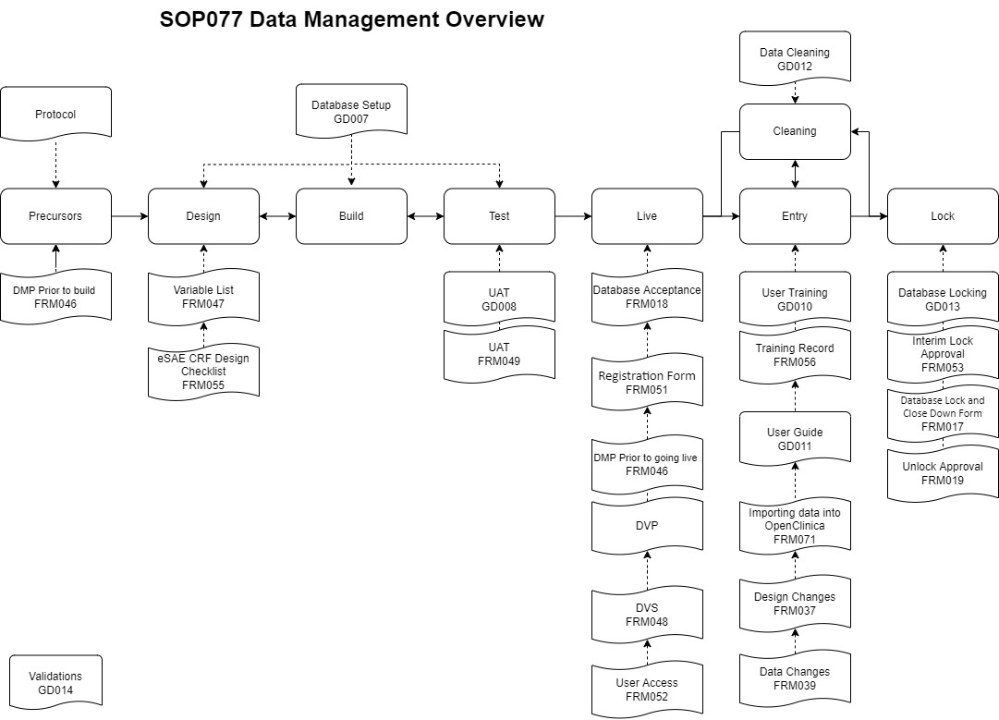

Appendix B Check List (Design and Setup)

This checklist should be reviewed during the design stage with the DML to determine which tasks are essential.

Task | Number | Completed | Date
Data Management Plan | FRM046
Variable List | FRM047
eSAE CRF Checklist | FRM055
UAT | FRM049
Data Validation Specification | FRM048
Database Acceptance | FRM018
Study Setup Specifications | FRM051
User Access | FRM052

