GD042 User Guide for Signing off SOPs in IQM

You will have been emailed a web link to access IQM (https://G15678.ideagenqpulse.com/qpulse )
Following this link will take you to the page seen below.
Click “launch product”.
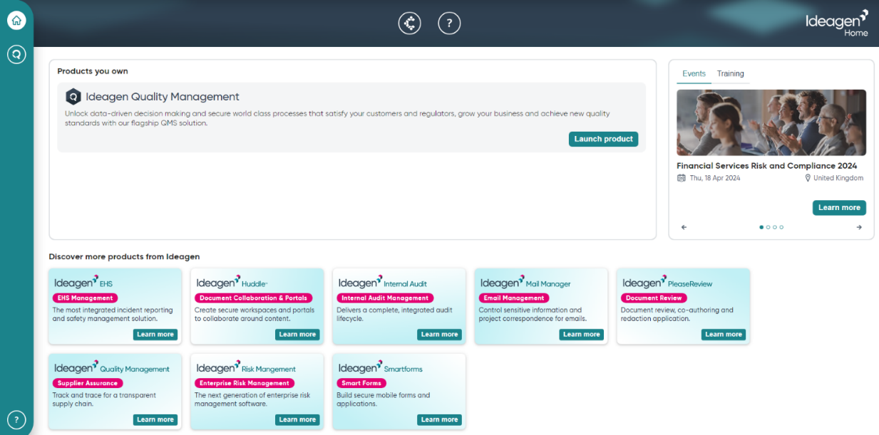

You will be taken to a login page where you have the option to select a data base. Please select “Live” from the drop down.

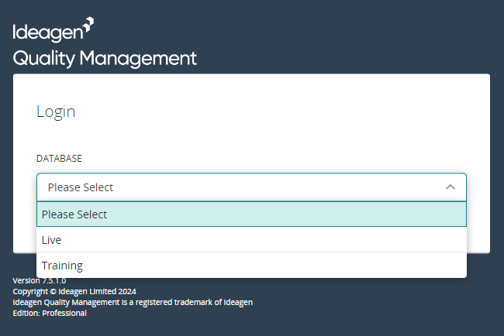

Next, enter your username and password. These will have previously been emailed to you. (You will be required to change your password when you first log in).
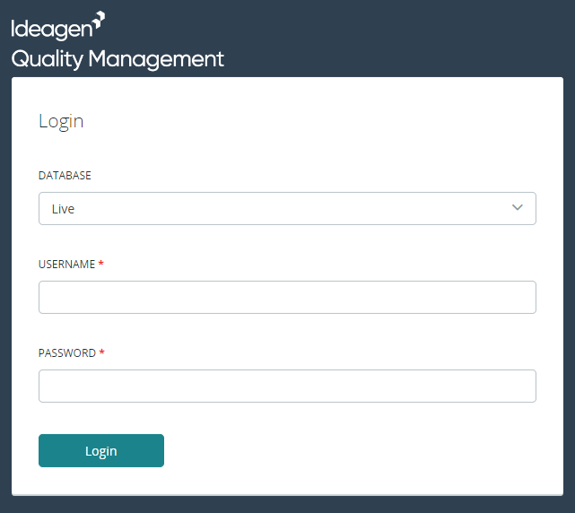

Accessing and reading SOPs
Once you have logged into the IQM website you will see the following home page

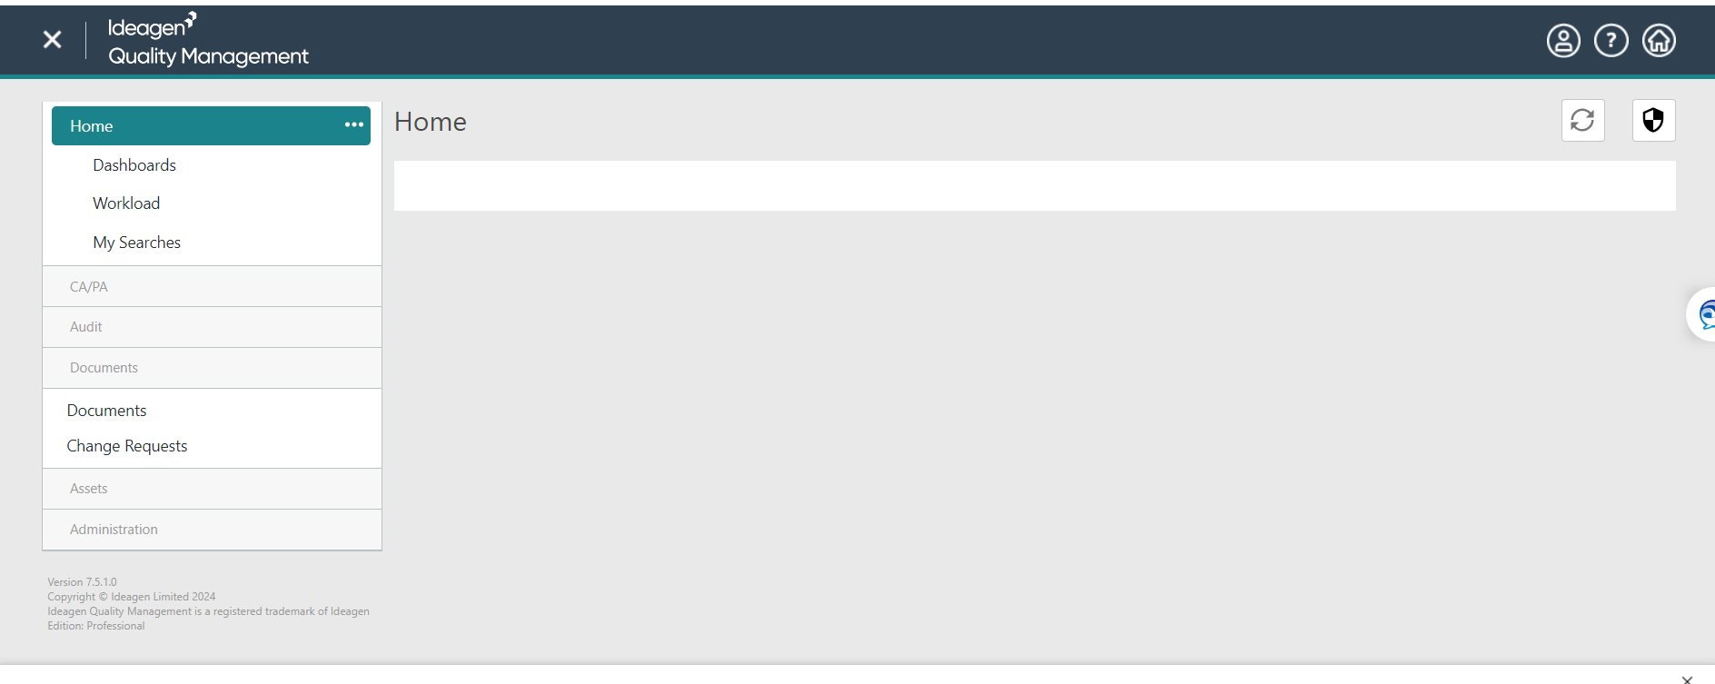

To view any documents/SOPs you have outstanding click on ‘Workload’ from the menu on the left

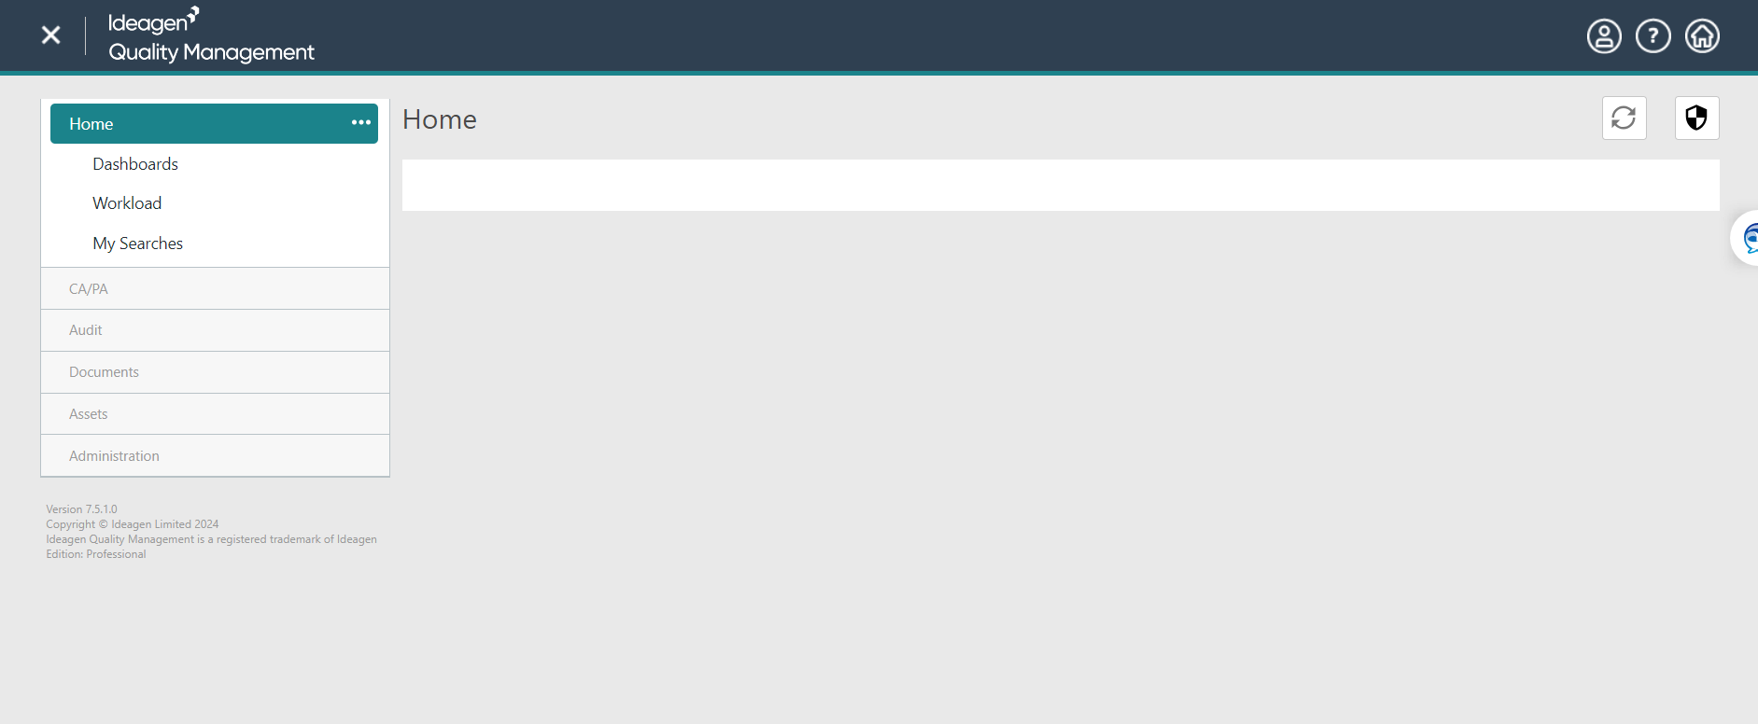

Workload shows your outstanding tasks for all modules. SOPs are saved in the Documents module. You can see below that there are 4 documents/SOPs to read and acknowledge.
Click the Documents row showing Distribution Acknowledgements.

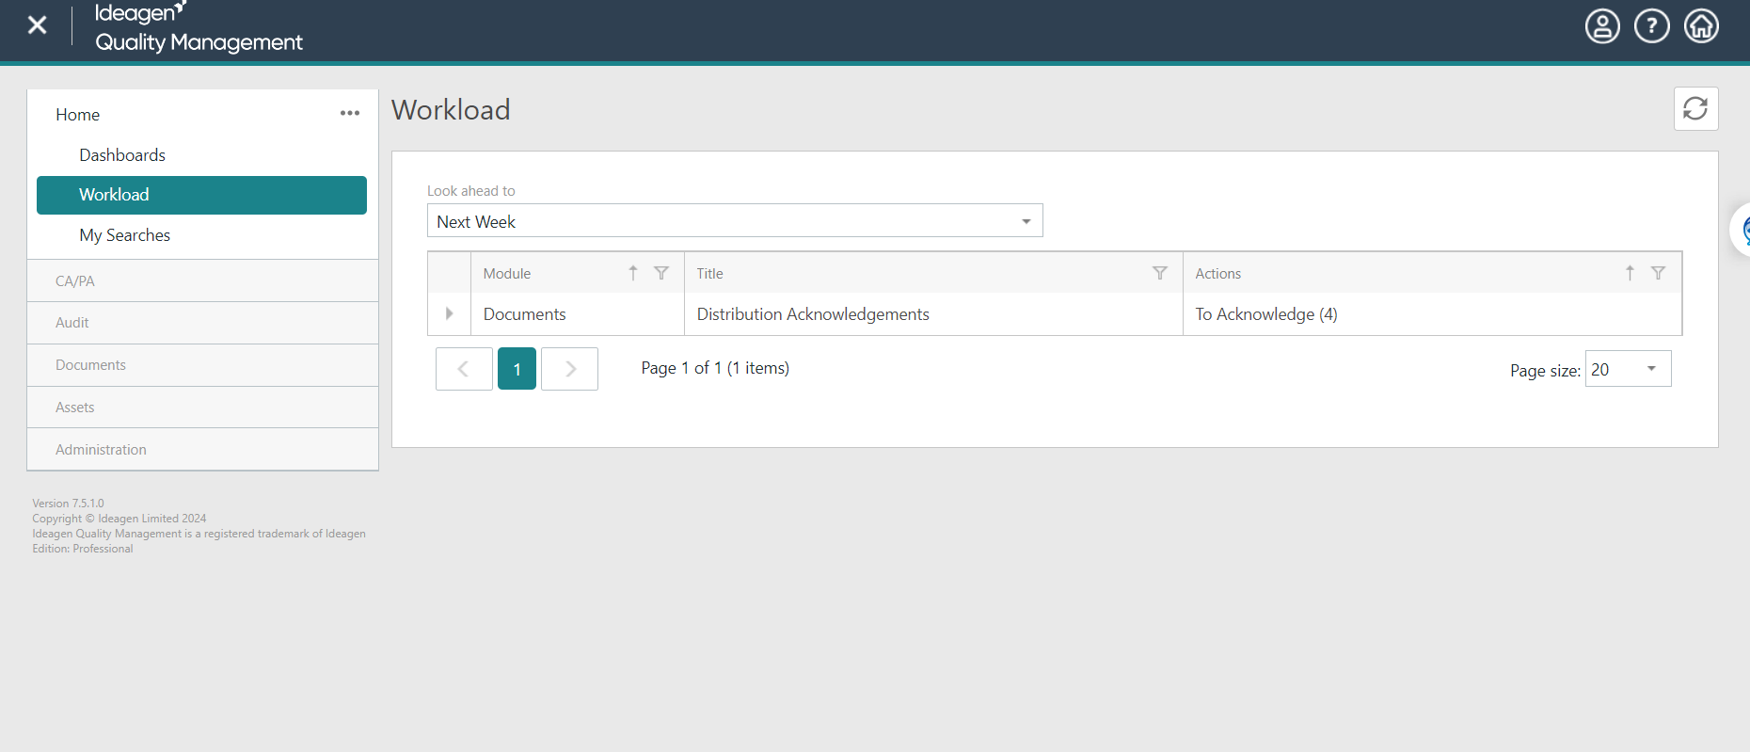

This opens another internet tab – unfortunately this is an error, and you need to click the x on the second tab to close it.

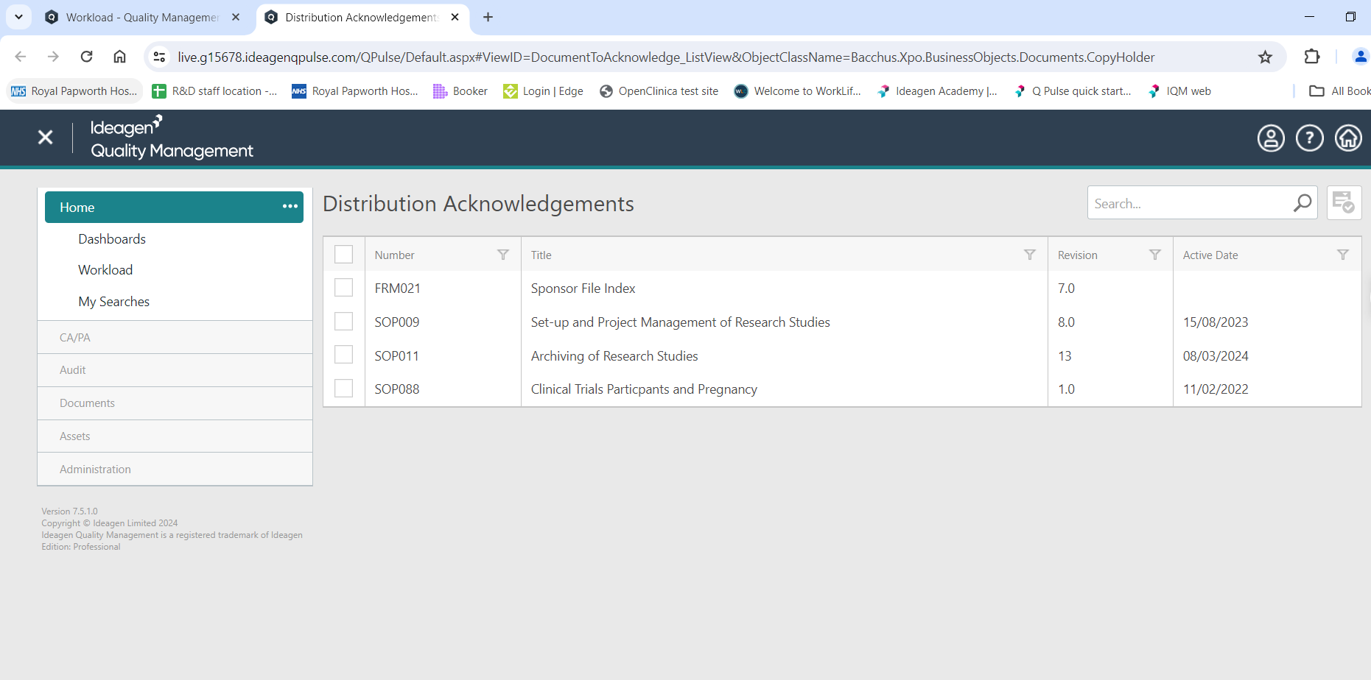

You are now back on the original tab.
Click on the row of the document you want to open – in this case SOP011.

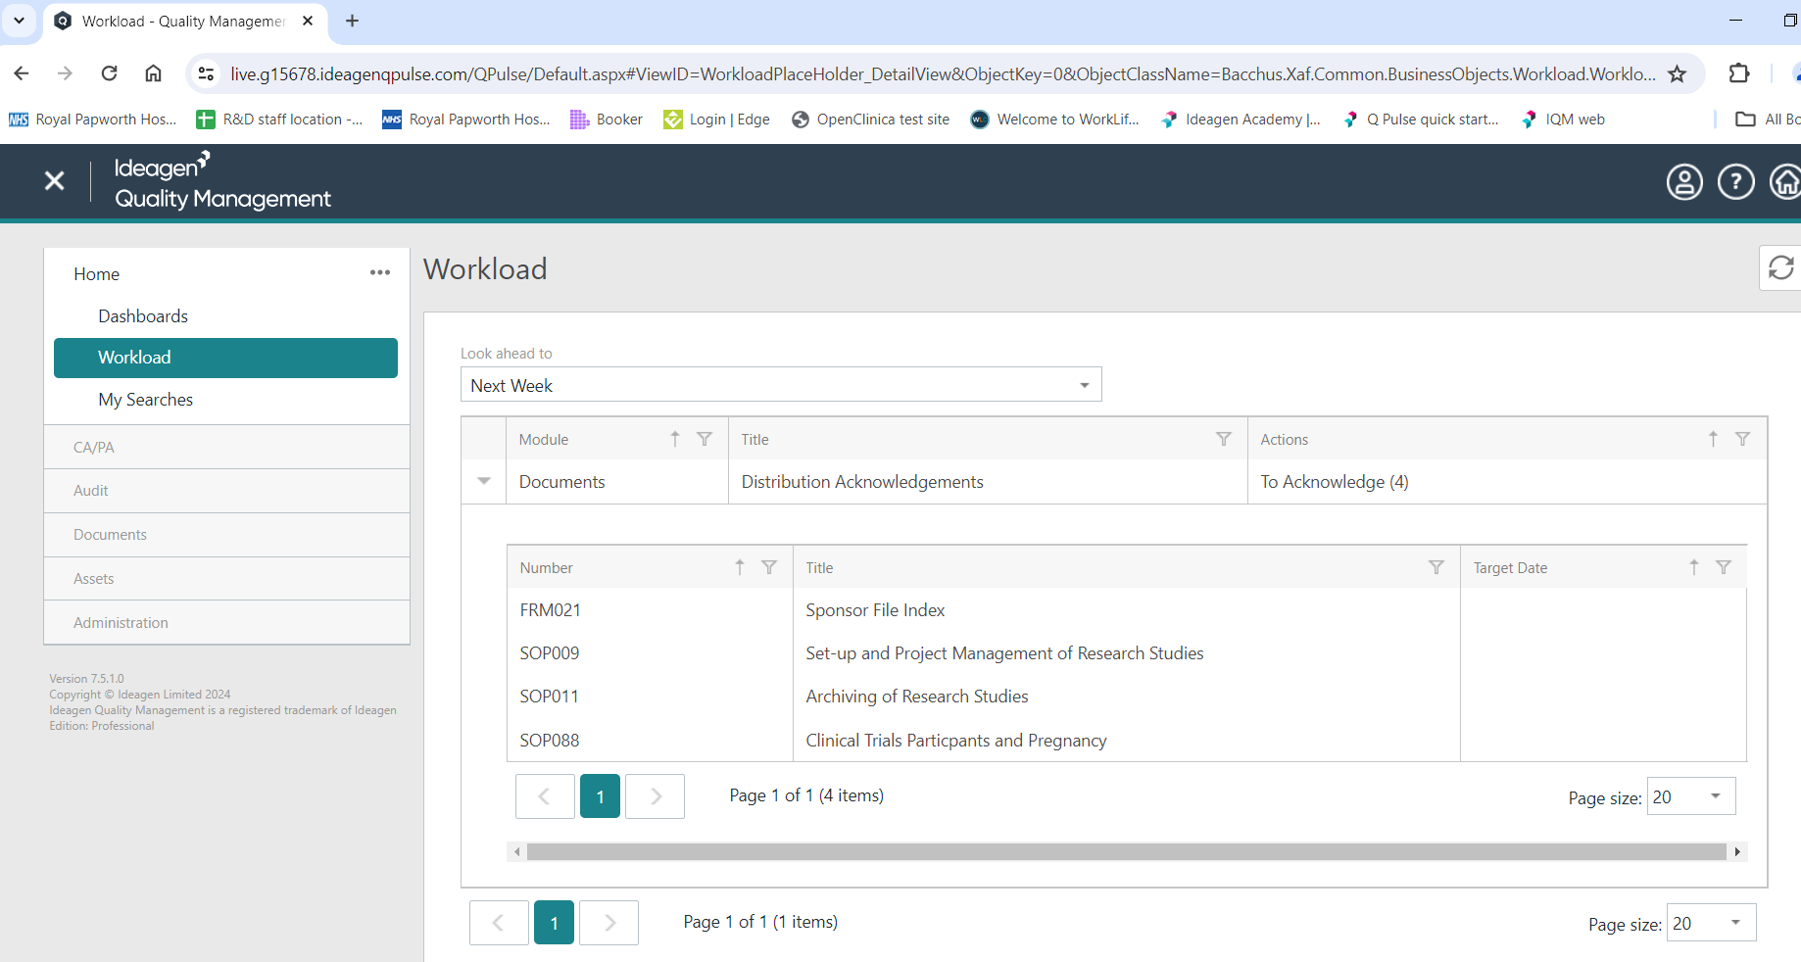

To read the document click on the Viewer tab

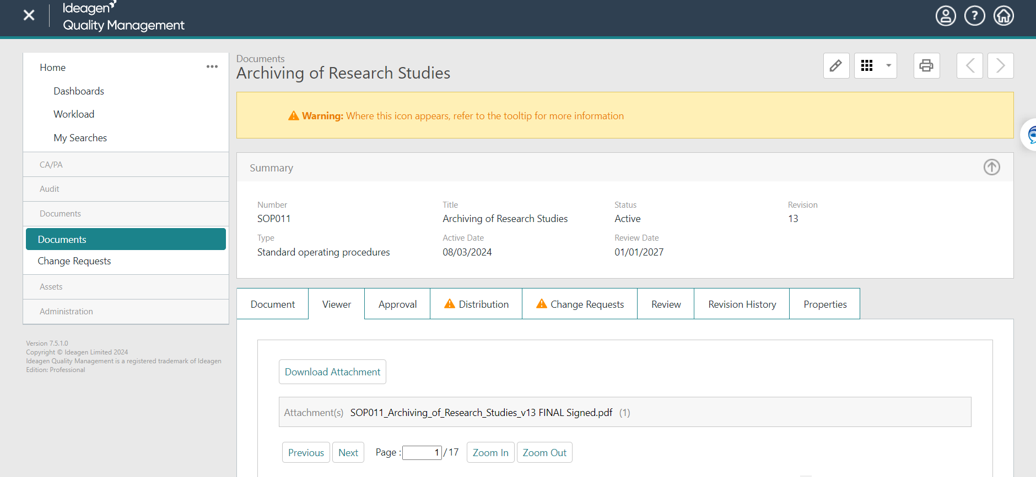
In the Viewer tab you can download a PDF version of the document (SOP) to read by clicking on Download Attachment.
Alternatively, you can scroll down and view the document in IQM. You can zoom in and out to make the document easier to read.

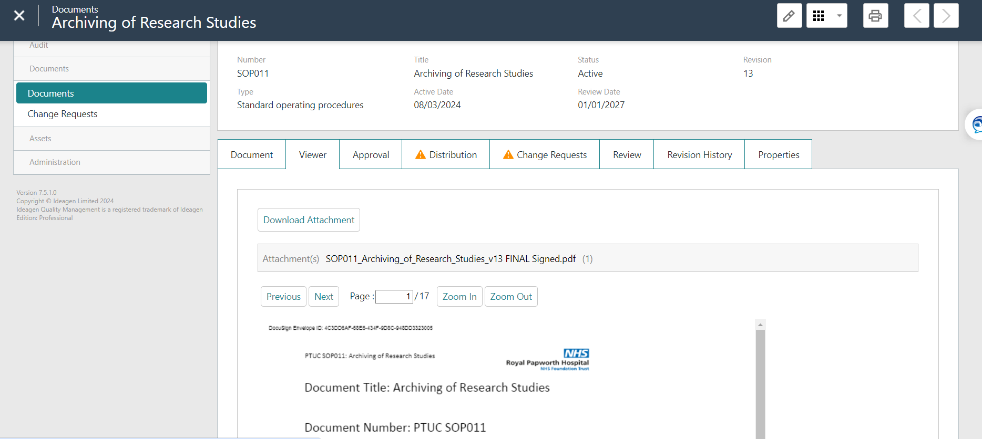

Acknowledging SOPs
Once you have read the SOP/document you need to acknowledge it.
To do this click on the Distribution tab. Click on the filter icon next to Name. Type your name in the text box and then select your name.

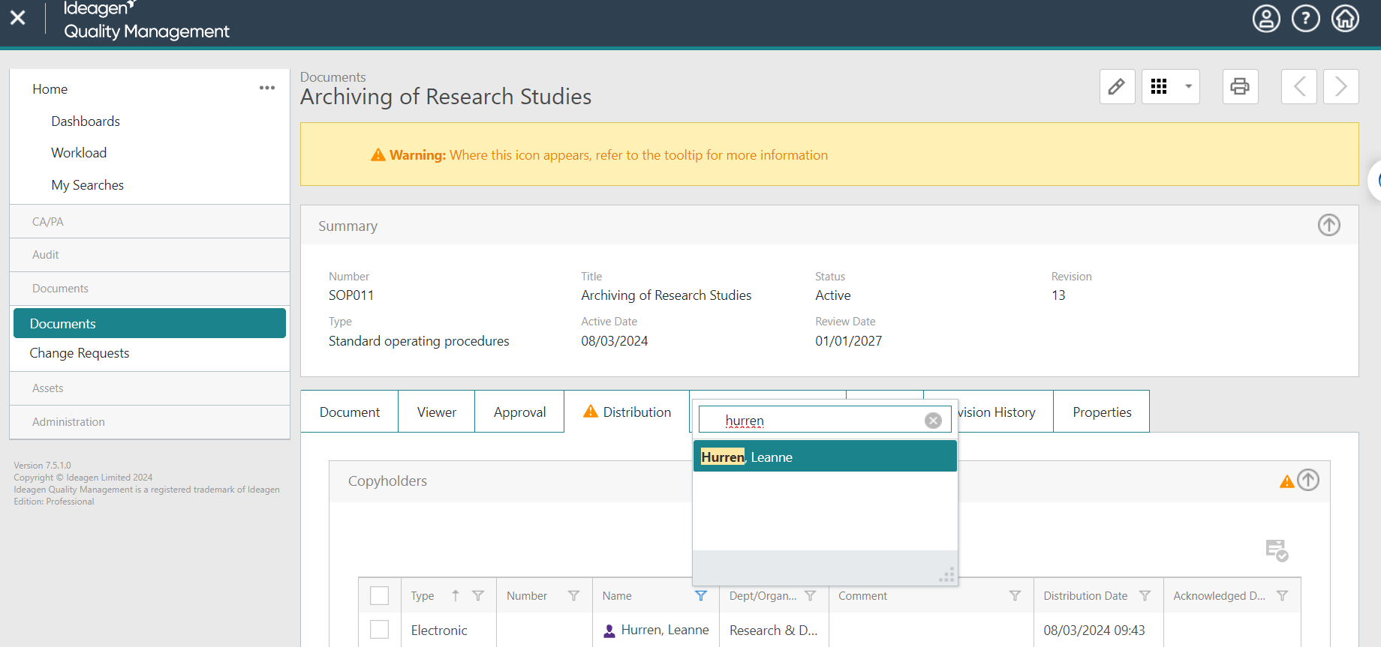

To acknowledge the SOP, click the check box to the left of your name to highlight the row and then click on the acknowledge button on the right.

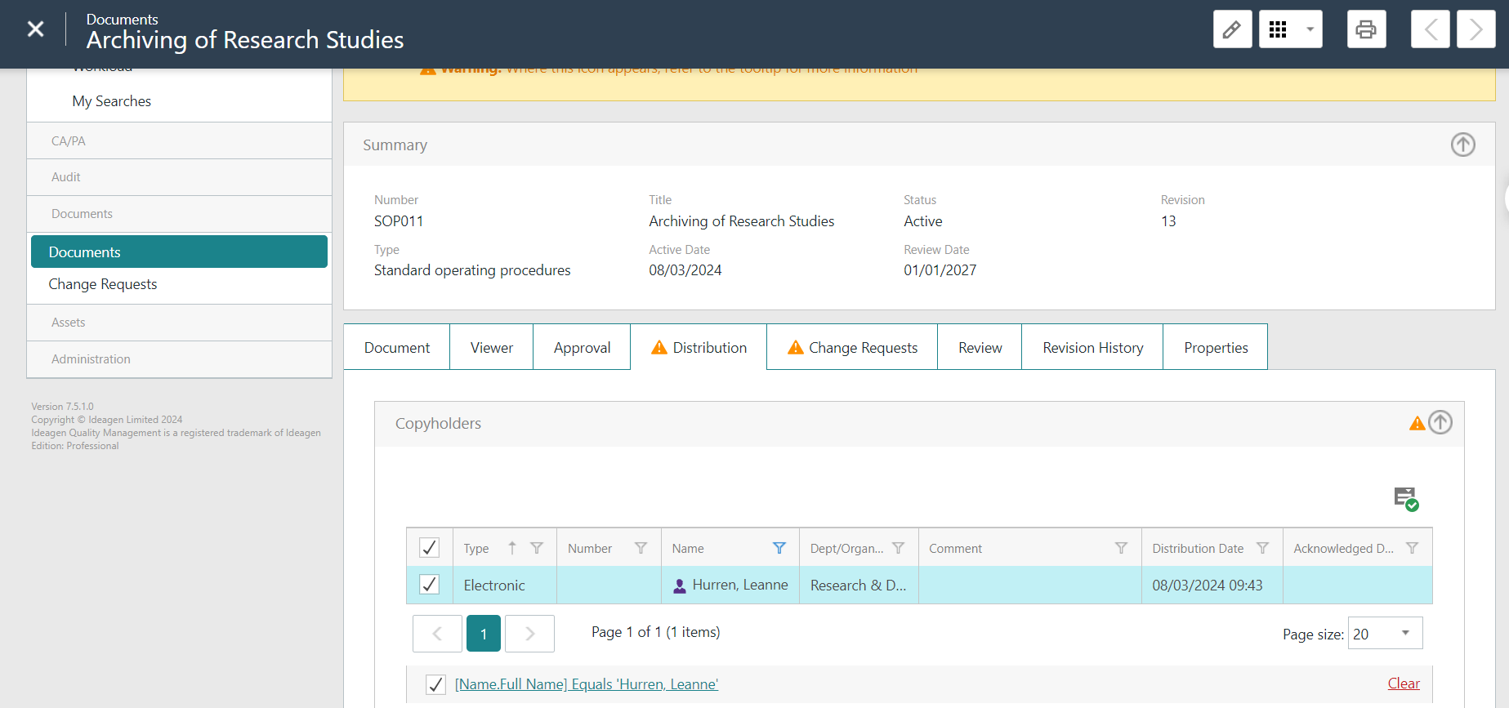

The acknowledgement date has now been populated.
Click on the save icon in the top-right to save the record.
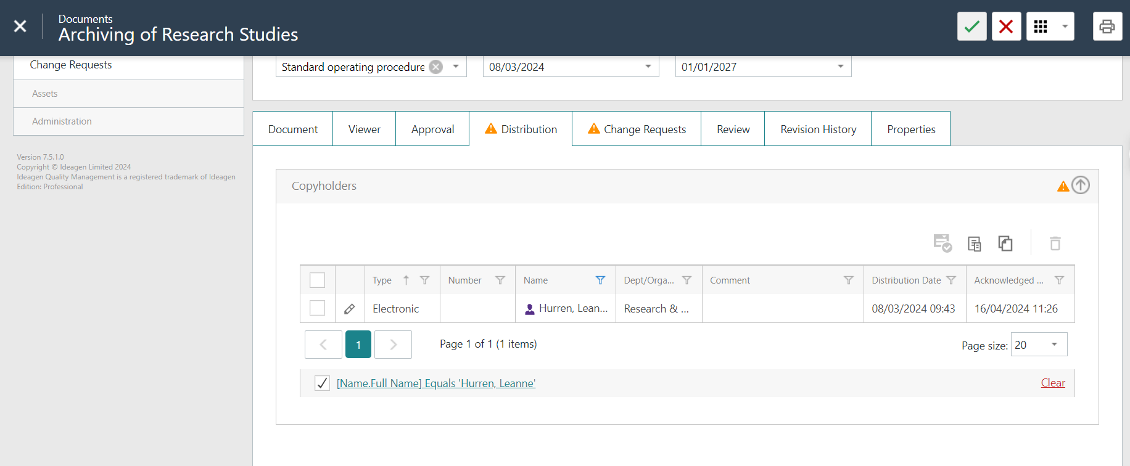

You will then be prompted to enter your username and password to electronically ‘sign off’ the SOP. Enter your details and click the sign button at the top of the signature panel.

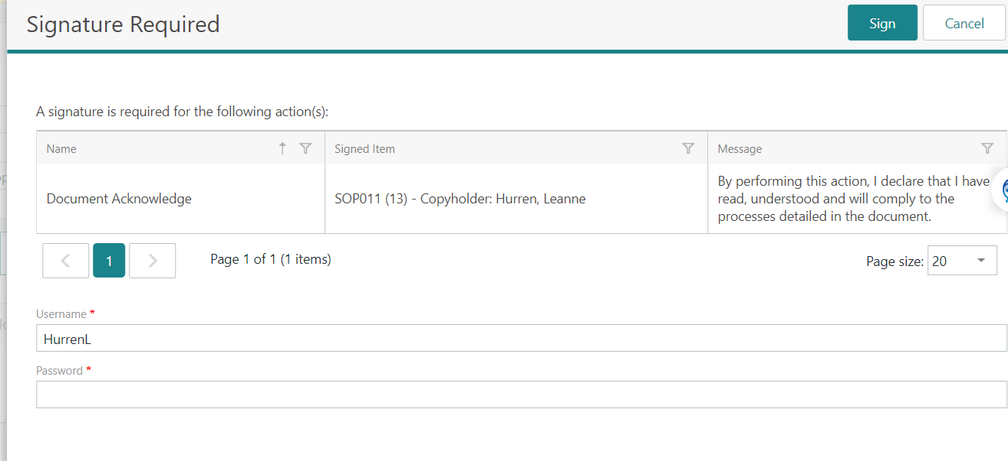

If you have more SOPs to read and sign off:
Click on Workload again in the menu on the left.
Then follow the instructions above to read and acknowledge each SOP (don’t forget to save!)
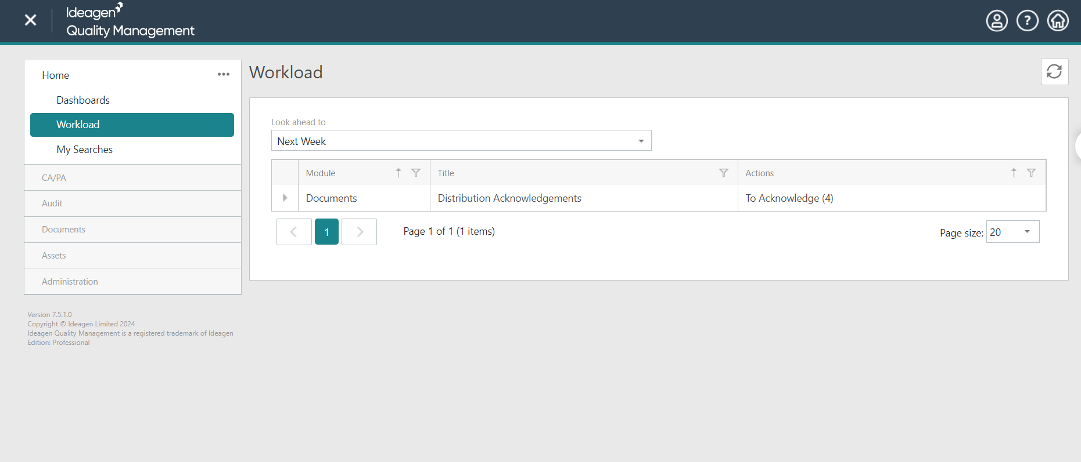

Closing IQM
Hover over the person icon in the top right corner of the screen – this will give you the option to ‘Log Off’ – click here to close the session properly.

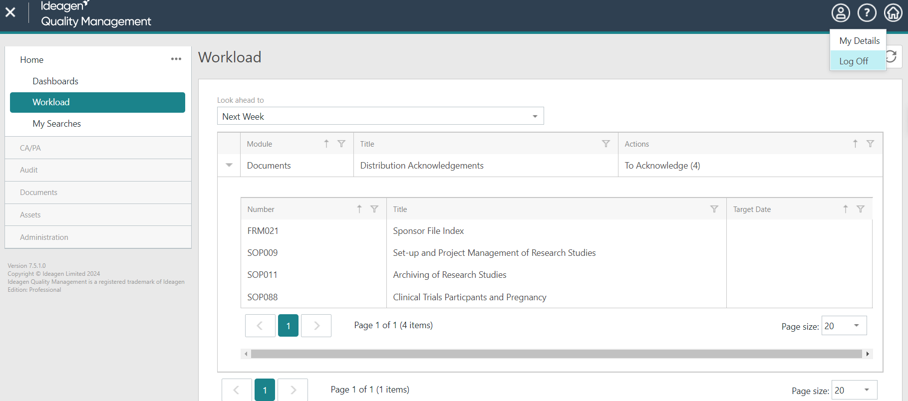

TIPS for IQM
To give you more space on screen, close the side menu by clicking on the X in the top left corner of the screen.

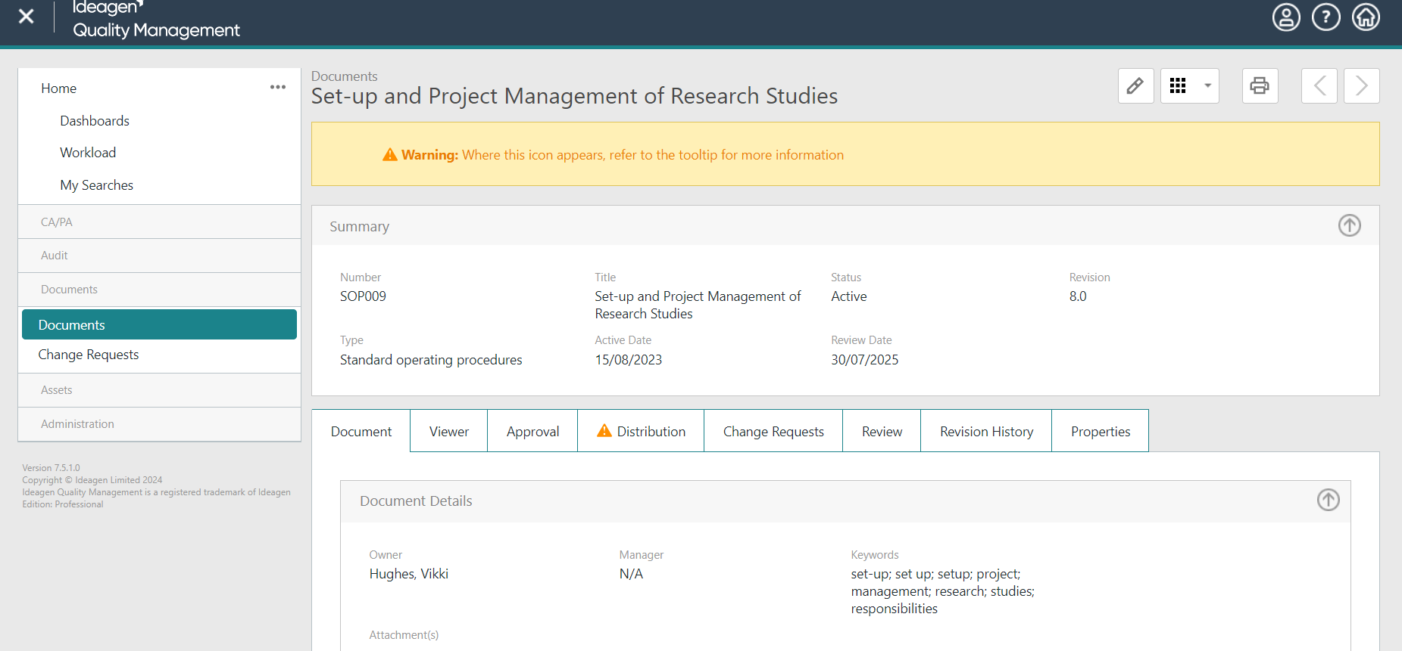

To open the menu up again click on the icon with 3 lines (top-left corner of the screen).

