OpenClinica User Guide

1.0 Accessing OpenClinica 2

2.0 Overview 3 2.1 Home screen 3 2.2 Menu bar 4 2.3 Subject matrix 4
2.4 Navigation 5
2.5 Adding a new subject 6
2.6 Scheduling an event 7

3.0 Accessing events 8

4.0 Entering data into the CRF 9 4.1 Entering data 9 4.2 Entering dates 11 4.3 Recurring events 11
4.4 Adding or amending data in a CRF marked as complete 12
4.5 Completing the ConMeds CRF 12
5.0 Notes & discrepancies 13
5.1 Discrepancy notes 13 5.2 Mandatory fields 14 5.3 Validated fields 14
5.4 Using a flag multiple time 15
5.5 Status of discrepancy notes 16

6.0 AE / SAE reporting 17
6.1 Adverse events 17 6.2 Serious adverse events 19

7.0 Marking the CRF as complete 22
8.0 Dealing with data queries 23 8.1 Queries raised by the study team 23 8.2 Responding to queries 24
9.0 Uploading reports 24
10.0 End of Study 25
11.0 Switching to another study 25
1.0 Accessing OpenClinica
You will receive an email from the study team providing you with a link to the OpenClinica website, your individual user name and password. This password will only be used for your initial sign in; you will then be required to enter your own password.
- To access OpenClinica, copy and paste this URL link into the Google Chrome or Firefox web browser: https://papworth.eclinicalhosting.com/OpenClinica/
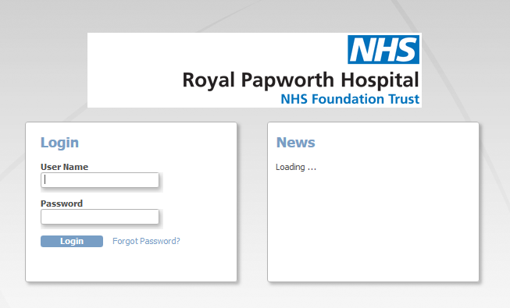

- Type the user name in the username field (the box under the words ‘User Name’). Use either the Tab key, or mouse-click (left click) in the Password field, to position the cursor in the password field; then type in your password.

- Hit the Enter key on the keyboard or click on the ‘Login’ button.

- The first time you log in, you will be forced to change your password and to set a ‘Password Challenge Question’. This could be your favourite animal, your city of birth, your mother’s maiden name or your favourite colour.

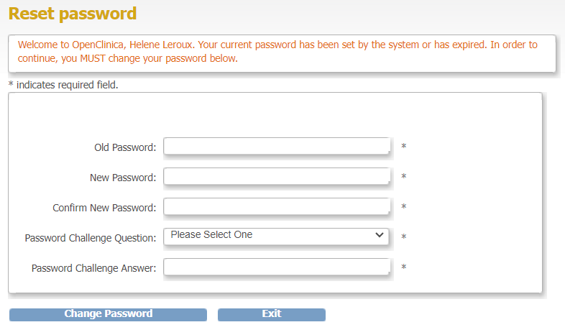

After the initial password change, your password will subsequently expire every 90 days and you will be forced to change it when you next login after the 90 days is up.

If you forget your password, click on the ‘Forgot Password?’ link on the login screen and provide your user name, email address and the answer to your challenge question. Your password will be reset and a new one emailed to you. You will be forced to change it after you log in with it. If you enter your login details incorrectly after 3 attempts, you will be locked out. Please email papworth.openclinica@nhs.net to request your account to be unlocked and password reset, make sure to include your username in the email and state whether it is on the live or test system.

To log out of OpenClinica, click on the ‘Log Out’ link at the top right of any screen.
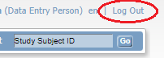

OpenClinica will automatically log you out after 20 minutes of inactivity. You will be required to re-enter your log in details and click on ‘Enter’. You will be taken back to the page that you were last on, if you were entering data, this will still be present.

2.0 Overview
2.1 Home screen
Data captured on the pCRF should be entered on to OpenClinica on the day it is collected, however where this is not possible, within 2 weeks.

Following successful log in, the home screen page will open. 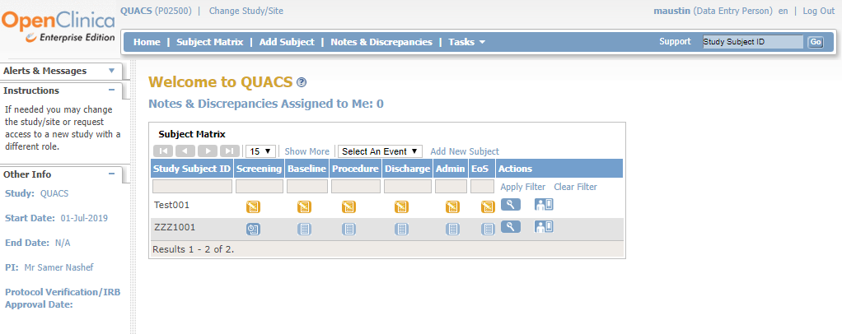

- Please ensure that you are accessing the correct study. You should see ‘Welcome to YOUR STUDY NAME’ in gold letters (in the screenshot example above, you will see the home screen for the QUACS study).

- If you are working on multiple studies sponsored by Papworth, you may need to change the study you see in OpenClinica. You can do this by clicking on the link at the top of the page ‘Change Study/Site’ and select the correct study and/or site from the list which will be displayed; scroll to the bottom of the list and click on the ‘Change Study’ button and when the confirmation page is displayed click on the ‘Confirm’ button.

- Below the headings is a table of all the subjects (patients) at your site that are entered into the study and all the events throughout the study.
2.2 Menu bar
A menu bar near the top of all screens gives fast access to various parts of the system.
You will find guidance on the menu bar options within this guide.

2.3 Subject matrix
The Subject Matrix page is similar to view as the home page. It can be accessed from the blue main menu bar of the Home screen.
The Subject Matrix lists all the study subjects from your site. Initially, these are shown in groups of 15 which can be increased to 25 or 50 using the drop-down control to specify the number.
There is a separate row for each patient added to the study. Each column within the Subject Matrix represents an event (e.g. Stage 1 Screening, Stage 1 Baseline etc. as seen in the example screenshot below). Each event might have multiple CRF pages to complete at a particular time point.
The event icon indicating the status of data entry for each event will change as the data entry progresses throughout the study. To the left of the Subject Matrix is a graphical key describing what each icon in the matrix indicates (circled in screenshot below):

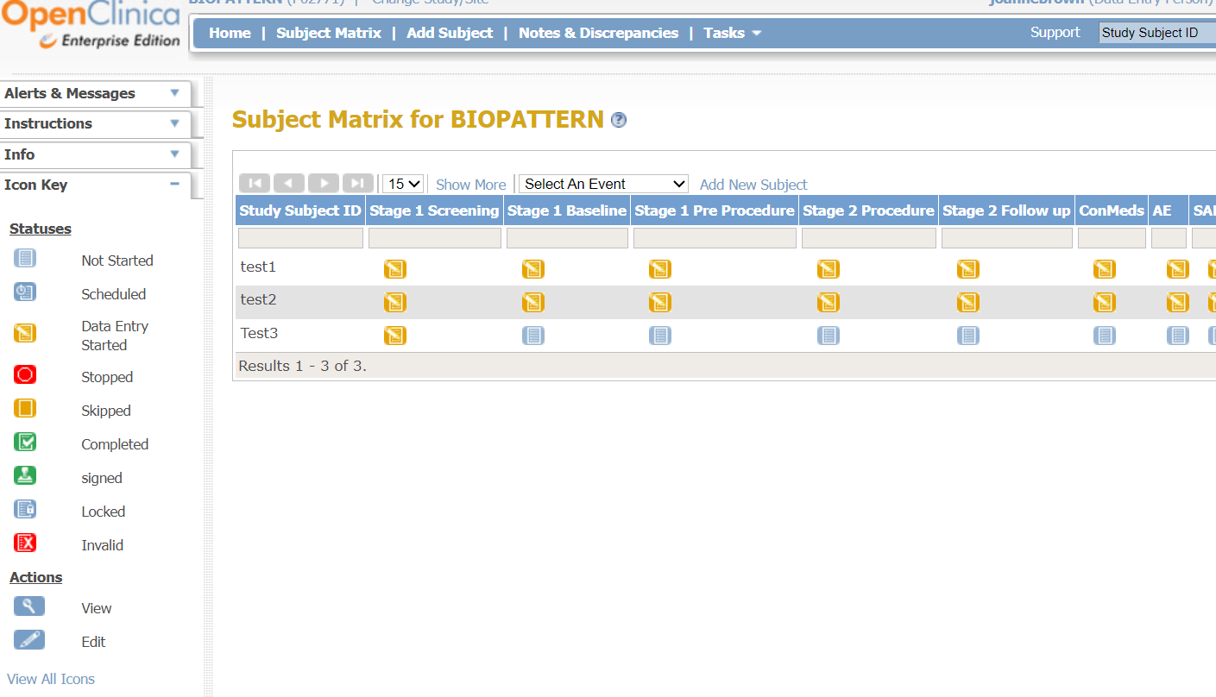

2.4 Navigation
There are four navigation buttons to move backwards and forwards through the Subject Matrix screen. These will be green if they can be used, or grey if they cannot be used (for example, if you’re at the first screen it’s not possible to go back any further so those buttons are greyed out). The left-most and right-most navigation buttons take you to the first and last pages while the two middle buttons take you back one page or forward one page.
The ‘Show More’ link un-hides some additional columns (Status, Site Id, OID, Sex, etc.)
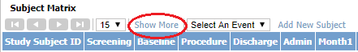

It then becomes a ‘Hide’ link in case you wish to hide those columns again.
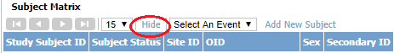
You can search for a particular study subject by typing all or part of the Study Subject ID into the field at the top of the column. The search is not case sensitive.
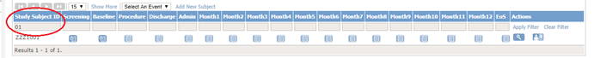
To list all study subjects again, simply delete the search string from the search field and press Enter on the keyboard or click on the ‘Clear Filter’ button (shown below).
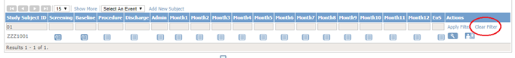
You can also search for a study subject using the search field on the menu bar (shown below). You can enter all or part of the Study Subject ID. If you enter the full ID, the View Subject page will open for that patient.
To find patients with a specific status, click in the empty field at the top of the appropriate CRF column (Screening in this example) and select that status from the list which pops up.
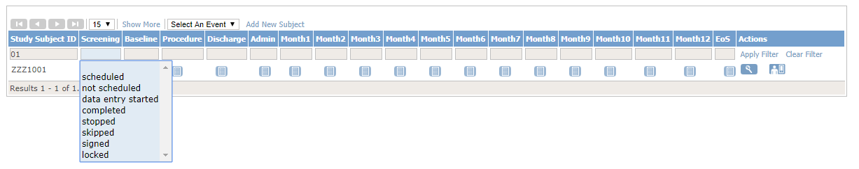
2.5 Adding a new subject
All patients who entered the study should be entered onto OpenClinica.
- To add a new patient, select the ‘Add New Subject’ link from the Subject Matrix page.
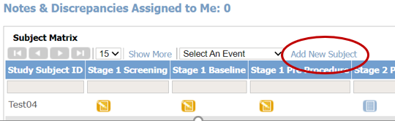

- You will be prompted to add information to the ‘Add New Subject’ page. All fields marked with * are mandatory fields and must be answered.
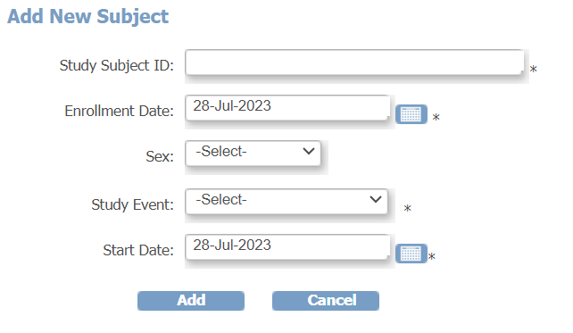
- The Study Subject ID is the patient identification number. This format of the ID will be confirmed to you at your SIV.
- To enter a date into the Enrolment Date field (this is the date the patient consented to the study), select the small calendar icon next to the data field and scroll through the calendar using the arrow icons. Using the calendar icon will ensure the correct date format is used. There is further guidance on using the calendar in this guide.
- The next data field, sex, is not a mandatory field and does not need to be answered.
- Select the Study Event field and highlight the appropriate event, for example ‘Screening’.
- Once all the required fields have been completed, select the ‘Add’ icon. The patient has now been added to the Subject Matrix. You can return to the Subject Matrix page by selecting the ‘Subject Matrix’ icon on the blue banner at the top of the page.
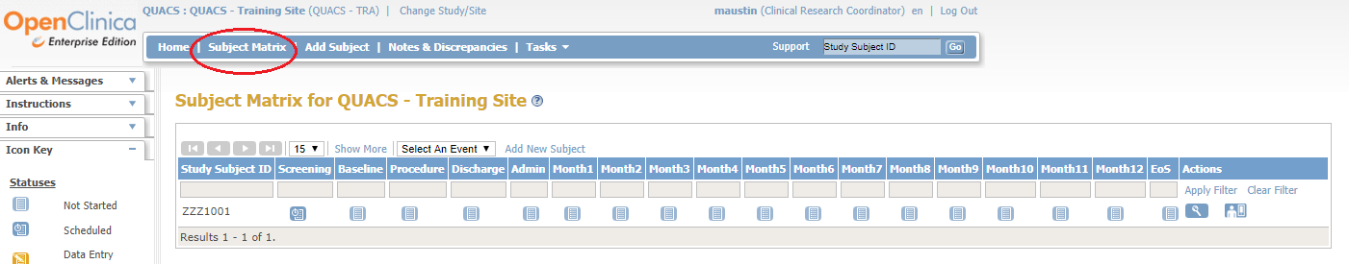
Your patient will now show in the Subject Matrix for your site.

2.6 Scheduling an event
At your SIV, you will be made aware of the events that your site will be responsible for completing on OpenClinica.
Once you have added the new subject to OpenClinica, the first scheduled event will usually be the Screening event. A scheduled event is indicated by this icon . This will be the only event that will be scheduled automatically when you add a new subject to the study; you will be required to schedule all further events manually. If an event is not scheduled, then you will see this icon .
Events can be scheduled as the subject progresses through the study, it is NOT required that all events are scheduled at the start of enrolment.
To manually schedule an event (for example, Stage 1 Baseline as shown in the screenshot below):
- From the Study Matrix, find the subject ID (for the example below it is Test04) and then click on thebutton under the ‘Stage 1 Baseline’ header (circled in red below).

- Click on ‘Schedule’ (as shown below) from the pop-up box that appears.
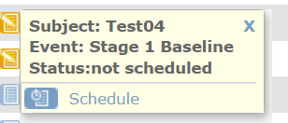

- Enter a start date in the ‘start date/time’ field. This date should be the date the visit occurs. This is the only field that you are required to complete. Click on the ‘Proceed to enter data’ button.
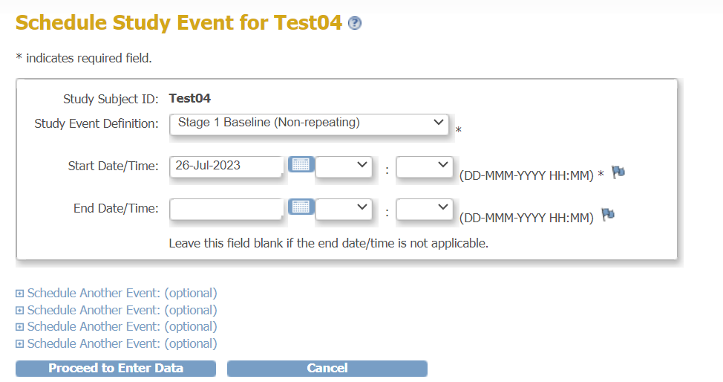
The event is now scheduled, and you can start to enter the data for that event.

3.0 Accessing events
CRFs can be accessed from the Subject Matrix menu by clicking on the icon of the subject and event you wish to access. The following sub menu will appear:
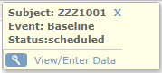
Click on ‘View/Enter Data’. You will be presented with the CRFs that are relevant to that event. In the example below, you can see the Baseline CRF that needs to be completed for the QUACS study (circled). To enter data for a CRF, click on the pencil icon in the ‘Actions’ column (marked by the arrow).
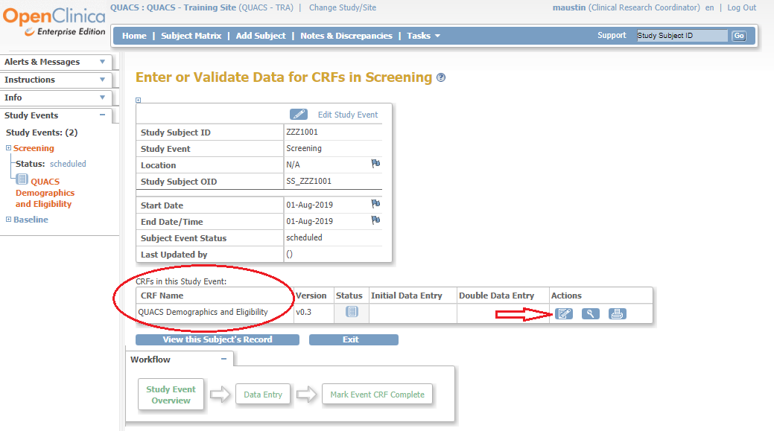
Things to note:
- The version number will automatically be set to the correct version.
- The magnifying glass icon allows you to view data without being able to change it. Please ensure that you are not in ‘View’ mode when you are entering data as you will not be able to save it.
- The printer icon allows you to print your CRF, this will include any data already entered into the CRF.
- The button will bring up a page listing all CRFs from all events for that subject.
- The button will take you back to the Subject Matrix.

4.0 Entering data into the CRF
4.1 Entering data (once you have scheduled and accessed an event)
After clicking on the edit icon in the ‘Actions’ column, a blank CRF will be displayed. A CRF that has more than one page will be indicated by the tabs shown at the top of the page (circled on screenshot below). Some forms have hidden tabs that will only appear if they are required to be completed, based on previous answers given to certain fields.

We recommend completing these tabs in order. However, you can move between them by clicking on the appropriate tab or by selecting the drop-down menu (see the arrow below).
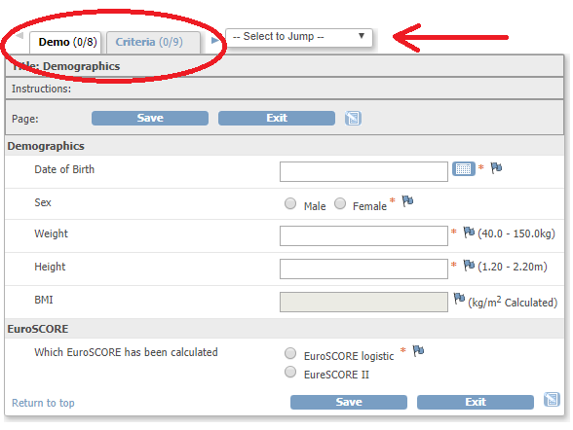
Once you have begun entering data on one of the tabs, this must be saved before moving on to the next tab. You will need to enter all mandatory data fields before saving (these are marked with an *).

To complete a CRF within an event:
  - Depending on the data field type, enter a date, a value, text, or click on the radio button next to the correct answer.

  - There may be occasions where you do not have the data that is required (please leave the field blank, do not enter 0), or that the data you have falls outside of an expected range. If this is the case, create an annotation note by clicking on the flag adjacent to the question (circled in green in the screenshot above). Please see ‘discrepancy notes’ for further guidance.

  - Once you have completed all the questions of the CRF, click on . You will then be taken to the next page of the CRF that requires completion.

  - Once you have completed all the pages of the CRF, click on the ‘Save’ button at the bottom of the CRF. You will notice that there is the option to ‘mark the CRF complete’. Only tick this box if you are sure that all the data entered is complete and correct (see section on ‘Marking the CRF as complete’).
Once you have completed all the CRF pages and clicked on ‘Save’ you will be taken to a screen similar to this one below:
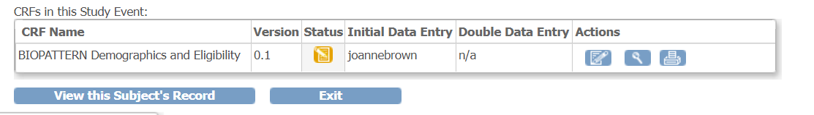

This page provides confirmation of the CRF(s) that you have completed and shows the status of that CRF. In the screenshot above the status is (initial data entry complete). If the ‘mark CRF complete’ box had been ticked on the CRF, then this status would show as (data entry complete).

You will also have some further ‘action’ icons which will allow you to:
edit the CRF further (as long as the CRF has not been marked as complete). If the CRF is complete, you will be required to provide a reason for change by raising a discrepancy note;
view the data that has been entered into the CRF;
print the data from the CRF.

To return to the subject matrix page, click on either the ‘Subject Matrix’ on the blue menu bar at the top of the page or the ‘Exit’ button near the bottom of the page (both options are shown circled below):
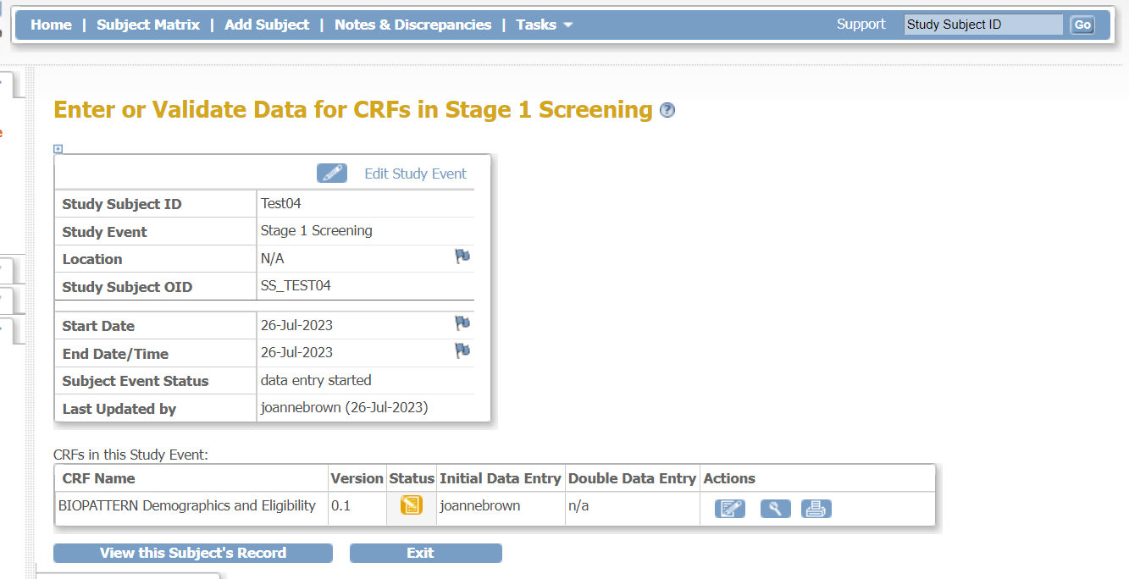

You are now back at the subject matrix for the study. You have various options available to you which can be completed by repeating the steps above:
- complete further CRFs for the same study patient;
- complete CRFs for other study patients;
- add another new patient to the study.

4.2 Entering Dates
All data fields that require a date have a calendar button next to them. When this button is clicked, a calendar is displayed:

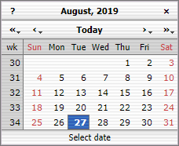
To change the year, click on << or >>. To change the months, click on < or >. Once you have the correct month and year, you can click on the correct day of the month to populate the field on the CRF.
You can enter a date manually, but the correct format of DD-MMM-YYYY must be used (e.g., 27-Aug-2019). The month is not case sensitive but must be entered as a word and not a number.

4.3 Recurring events
Some events may be reoccurring, i.e. can occur more than once during the study. For example, it is possible that a patient may experience more than one serious adverse event, thus requiring the completion of multiple Serious Adverse Event CRFs.

To add another occurrence, click on the icon for the event you want to add another occurrence to, and click ‘Add Another Occurrence’ (see below).

You will then be asked to schedule it (see previous section on Scheduling an Event).

Such events have a times number next to the icon e.g. x2 (marked by the arrow on the screenshot above).

These recurring events will become layered on top of each other (rather than a separate column for each). Where applicable, click on the multiple icon to bring up the separate entry points to the individual event. See example below:

4.4 Adding or amending data in a CRF marked as complete
If you have additional data to enter or to edit data already entered on a CRF marked as complete:
- Open the CRF using the edit button .
- Go to the question or data field you are required to change and make the required change or addition.
- Click on the corresponding flag for the amended field – a pop-up box will appear.
- Enter a brief description of why a change is being made (e.g., data correction, new information).
- From the ‘type’ drop down box, select ‘Reason for change’.
- Click ‘Submit and exit’.
- The pop-up window will close and you will be taken back to the CRF.
- Remember to click on ‘Save’ to save the changes made and the CRF will close.

4.5 Completing the ConMeds CRF
All concomitant medication taken by the participant will be recorded in this CRF. Choose the medication from the drop-down menu and complete all the other required fields. The ‘Medication Group’ will autofill after saving the form, unless you have selected ‘other medical not listed (specify)’.

The complete and exact start date will be needed for every conmed linked to an adverse event. For the others, you can select an estimated medication duration if the start date is unknown.

To add a row, click on . If a row is created by mistake, click on at the right end to remove it.

Please do not mark this CRF as complete until the participant has finished the study.

5.0 Notes & Discrepancies

5.1 Discrepancy notes
You can create a ‘Discrepancy Note’ at each question field during data entry, to provide any information about the data that cannot be adequately represented in the CRF (for example, if the value is not as expected or the data is not available). To generate a ‘Discrepancy Note’:
- Click the button next to the data field (circled below):
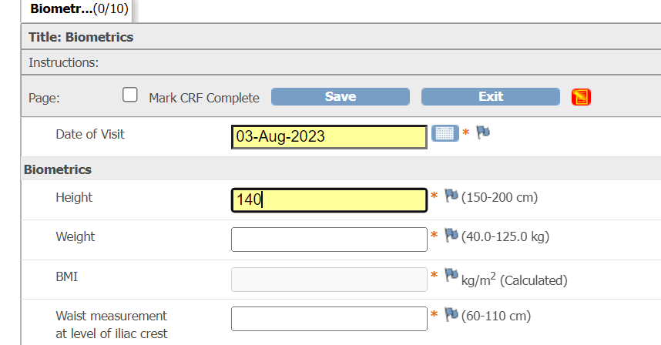
- The ‘Add Discrepancy Note’ window will now open for you to complete.
- The ‘Description’ is a mandatory field and will require a brief comment which explains the reason for the Discrepancy Note. You then have the option to add further information in the ‘Detailed Note’ field. The information added to the ‘Description’ and ‘Detailed Note’ field will be used by the study team to determine the next action.
- Select the type of ‘Discrepancy Note’ from the drop-down list. This will usually default to the appropriate option.
- The ‘Set to Status’ drop-down box is automatically set to the correct option and will not need changing.
- Once completed click on ‘Submit & Close’ button (circled below). Do not click this button more than once as it can cause multiple responses.
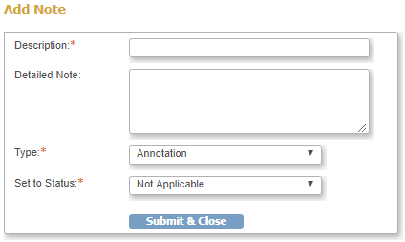
- The flag next to that data field will now change colour depending on the status/type of the discrepancy note.
- If a data field already has a discrepancy flag and you wish to add another, click the flag next to the field and then in the window that appears, click ‘begin new thread’ (circled below):

5.2 Mandatory fields
All fields marked with * must be answered. If they are left empty, an error message will appear requesting for the data to be entered. If you do not wish to enter data in this field, you can make a comment by clicking on the flag next to the data field to explain why the data is missing.

5.3 Validated fields
Some data fields will only accept certain values. They may have certain rules for example an expected range for height, only accept number values, have a strict date format or be a mandatory field which cannot be left blank.

On completion of a CRF, OpenClinica will automatically check the data that has been entered and if issues are found, it will trigger a ‘Failed Validation Check’ notification. If this happens, an error message will appear warning that you have failed one or more validation tests. The field with errors will be visible by a red exclamation mark; the error will also be listed underneath the CRF header (see screenshot below).

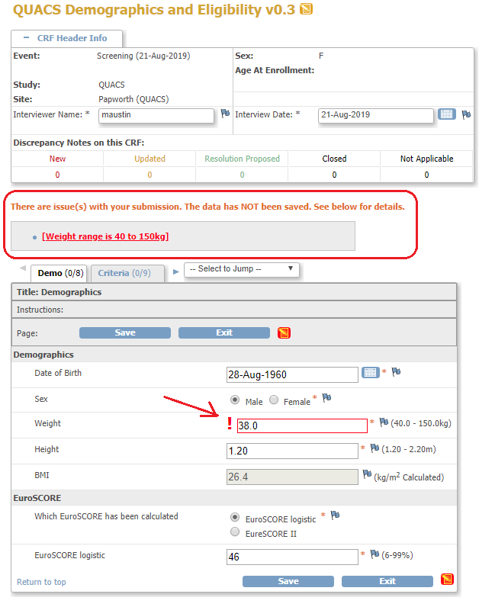

You can resolve this issue by correcting the data field and clicking ‘Save’ or by clicking on the flag icon and using the pop-up box to provide and explanation for either the missing, incorrect or outlaying data (see screenshot below).

Enter a brief reason in the ‘Description’ box. This could be for example, to confirm that the data is correct even though it falls outside of the parameters set for that data field or that the data is missing and will not be completed. Any further details can be added to the ‘Detailed Note’ section. Once completed, click ‘Submit & Close’.

Please Note: do not click the ‘Submit & Close’ button more than once. Repetitive responses may be entered if you click more than once.

A confirmation screen will appear which will close automatically.

You will be required to repeat this process for all data fields that have failed the validation check. When you have finished dealing with all the ‘Failed Validation Checks’ you must ensure that you press save on the CRF.

5.4 Using a flag multiple times
Flags can be used more than once, for example if you need to make another change to a field where you have already completed a ‘Reason for Change’ (thus the flag is already white).

To make another change to the field where the flag has been previously used:
- Make the change required and select the flag next to it.
- Select ‘Begin New Thread’ - a new box will open.
- Select ‘Reason for Change’ and complete.

Please Note: The audit history displays the previous version of the field. Only one colour can be displayed on the flag. If a flag has a query and annotation note, the colour shown would be RED, as the query has a higher priority.

5.5 Status of a Discrepancy Note
The status of a Discrepancy Note provides an indication of who is responsible for the next step. The colour of the flag will change depending on the status:

NEW This flag means that the query is ‘new’ and requires attention.

UPDATED This flag means additional information is added to a ‘new’ flag and then the user has clicked ‘Update’. When the information is added, click on ‘resolution proposed.’ (It is also okay to click on ‘update’ when answering the query).

An example of this flag colour is that the user is responding to a Note, but the response requires further information.

Another example of this could be responding to a new Discrepancy Note by explaining that you are waiting on information and will answer the query when possible.

RESOLUTION PROPOSED A response/resolution to the query has been provided with the expectation that the issue can now be resolved.

CLOSED A resolution has been proposed, accepted and closed.

BLANK No Discrepancy Notes have been created.

ANNOTATION A Note has been made about this field.

6.0 AE/SAE Reporting
Should your study require recording of Adverse Events and Serious Adverse Events, please use the following as guidance. Always refer to your study protocol for information regarding AEs and SAEs.

6.1 Adverse Events
Research staff will be responsible for recording all adverse events within the AE table on OpenClinica. This event can be found on the blue headed row on the ‘Subject Matrix’ (circled below) and can be scheduled in the same way as other events. The ‘Start Date’ will be the date you are entering the information.

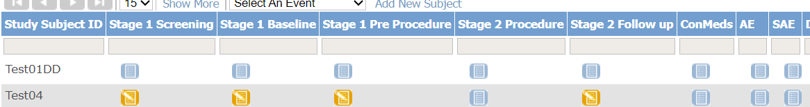

Once scheduled, the AE table can be added to throughout the patient’s participation in the study. Some columns within the AE table will require completion by the PI or Co-Investigator on delegation log, and they must be signed in to their own OpenClinica account when completing this. These columns will be highlighted in yellow.

Grey columns must be completed by site study team.
Yellow columns must be completed by the PI or Co-Investigator on delegation log. They must be signed in to their own OpenClinica account when completing this.
Purple columns are for medical coding of the AE and will be completed by the Sponsor team.

- Once scheduled, the first page of the AE CRF will show the question ‘Has the patient had any AEs or SAEs’. By selecting ‘Yes’ and then clicking ‘Save’, the AE table page (shown below) will appear for you to record these events.
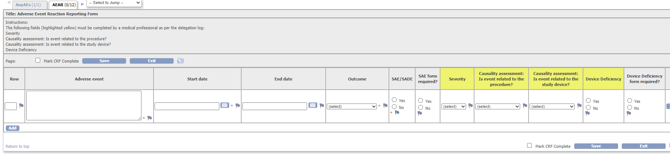

- Please do not use medical acronyms in the ‘Adverse event’ free text box as this may cause confusion. Instead write these out in full with as much detail as possible.

- As noted in the instructions at the top of the CRF, the fields highlighted in yellow must be completed by a medical professional (as indicated on your site delegation log).

- Additional rows can be added onto this table by clicking the ‘Add’ button at the bottom left of the page (circled above on the left). If a row is added by accident, and you have not yet clicked ‘Save’, then it can be removed by clicking the ‘X’ button at the far right of the row (as shown below).
- If applicable to your study, the purple columns requiring ‘coding’ will be used by yhe Sponsor team to code the AE events with MeDRA.

- When you have finished completing all the other questions of the AE table, click on ‘Save’ and the CRF will close.

- Important note: do not mark the AE events CRF as complete until you have completed any follow ups that are required, that a medical professional (as indicated on your site delegation log) has completed the columns highlighted in yellow and the sponsor team have entered medical coding.

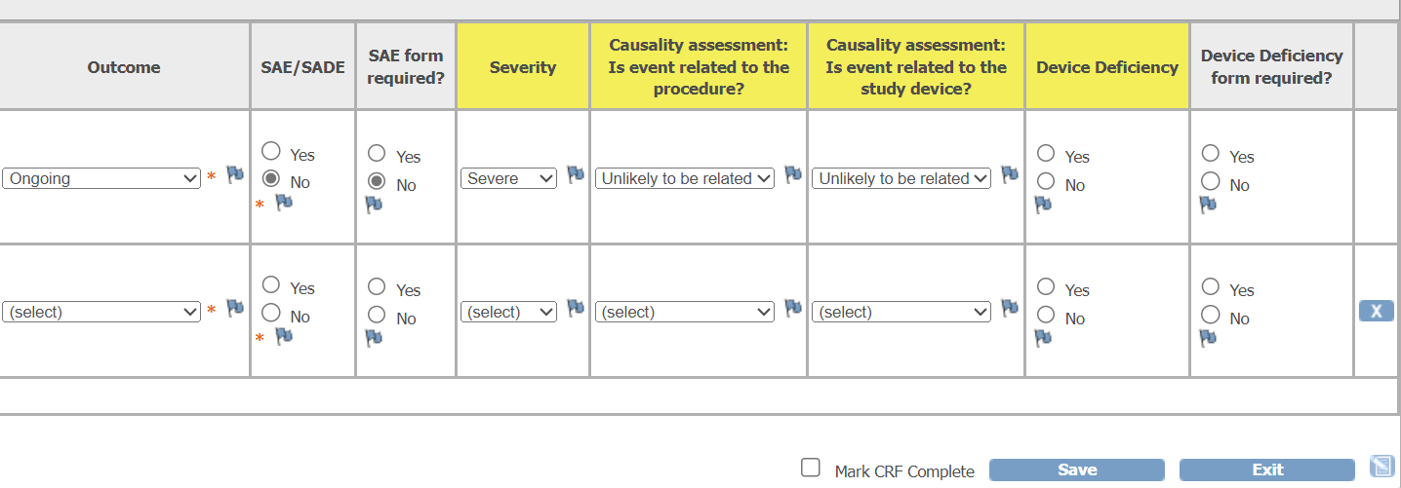

Important note if the patient has completed the study and there is an unresolved AE, the PI will need to determine if it must be followed up until resolution. If the PI decides that the AE is not clinically relevant and does not need follow up, the ‘outcome’ question will remain as ongoing but the PI will be required to add an annotation to the AE CRF within the ‘outcome’ column by clicking on the flag (circled in screen shot below) to record the decision that although the AE is ongoing, it is not clinically relevant and no will longer be relevant.

Below is an example of the annotation note that the PI will be required to add:
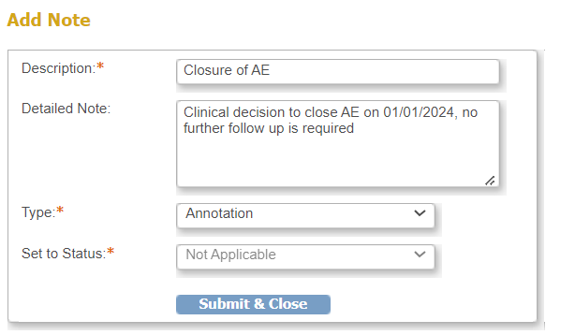

6.2 Serious Adverse Events
Please ensure that an SAE is recorded as an AE on the AE table first and then copy the Row Number for the Adverse Event on to the Serious Adverse Event table.

It is important that each CRF within the SAE event is completed by the correct person, please pay particular attention to the table below. When completing the CRFs, this person should be logged in to their own OpenClinica account.

CRF name within SAE event | To be completed by
SAE Initial Reporting | Site study team
SAE Medical Assessment | Only the PI or co-investigator on the delegation log
SAE PI Assessment | Only the site PI
SAE Sponsor Assessment | Sponsor team physician
SAE Follow Up | Site study team / co-investigator / PI
SAE Print | Read only – no need to complete
SAE USADE | Sponsor team

The site study team will be responsible for recording any serious adverse event on OpenClinica. This event is towards the right of the row on the ‘Subject Matrix’ (circled below) and can be scheduled in the same way that the other events are. The ‘Start Date’ will be the date you are entering the information.
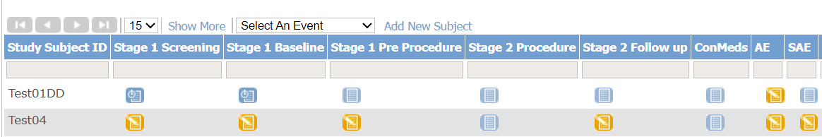

A new SAE event should be created for each separate SAE. If a patient has more than one SAE then subsquent SAE events can be created using the instructions provided in section 2.4 .

Once scheduled, the following CRFs will be shown for completion:
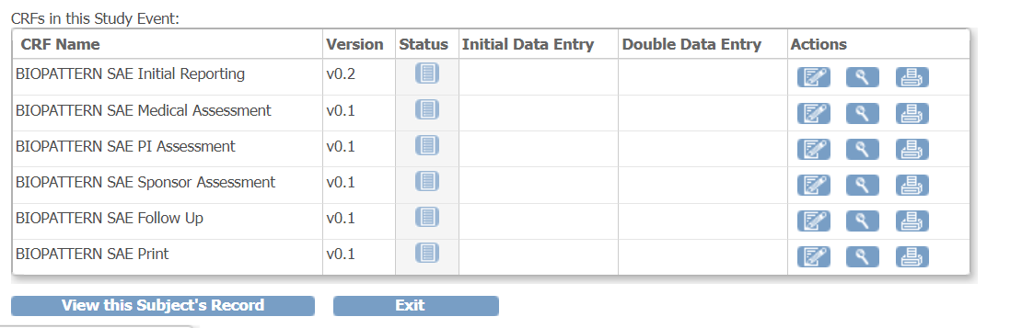

- The study team will begin by completing the SAE Initial Reporting CRF.
- Enter the AE Row number that the SAE relates to. If more than one AE row refers to the same SAE, choose the most relevant one.
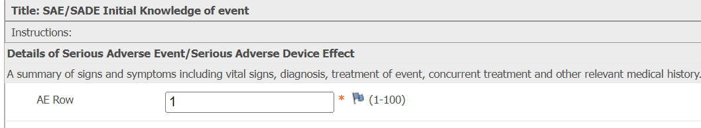
- Include as much detail as you can in the ‘Describe Event’ field.
- Complete all the mandatory fields. The ‘End time’ is only required if the event is resolved.
- Click on the ‘Save’ button at the bottom of the first page and then complete the second ‘page.
- When you have finished entering the required data, click on the ‘Save’ button, you will be taken back to the SAE list of CRFs shown above.

Once initial reporting data is entered and saved, you can mark the CRF as complete. Any follow up information provided should be added to the Follow-up SAE CRF, not the initial reporting CRF (see the section below on the Follow Up CRF).

- The SAE Medical Assessment CRF must be completed by the site PI or by a co-investigator who is on the delegation log.

- The PI assessment CRF must be completed by the PI.

- The SAE Sponsor Assessment and SAE SUSAR will be completed by the Sponsor team.

- The ‘print form’ CRF is read only. This can be used to print out the initial SAE reporting form to be filed in local medical records or scanned and added to local electronic medical records.

Completing the SAE Follow Up CRF
It remains the responsibility of the site study team to continue to follow up each SAE, until they are instructed not to by the PI.

The first tab within the ‘SAE Follow Up’ CRF will ask ‘is the SAE ongoing?’. This requires a ‘yes’ or ‘no’ answer. If the answer is no, then you can click in the ‘mark CRF complete’ box and click on the save button. The CRF will close and no further action is required.

If the SAE is ongoing, a new tab will open:
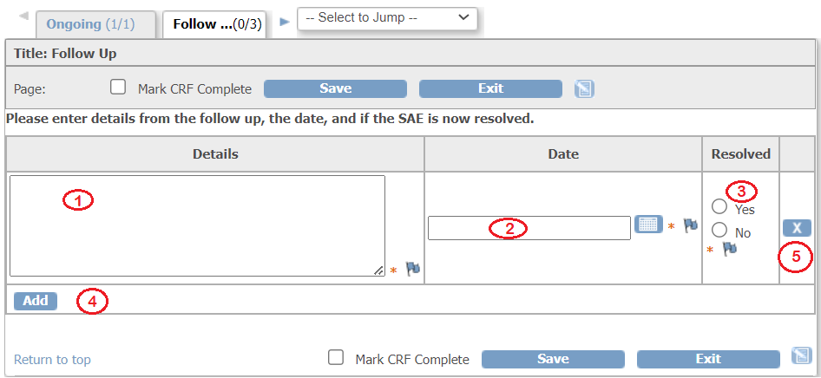
1. Add the details of the information gained relating to the SAE; this could be contact with the patient, an update from a physician, or an update from the medical notes.
2. Add the date that this information was received.
3. Mark if the SAE has been resolved.

4. The ‘Add; button will add a new row to the table.
5. If a row has been added in error, it can be removed by clicking on the ‘x’ button (this is only if the CRF has not been marked as complete).

Remember to click on ‘Save’ each time data is added to this CRF.

For any SAE that remains ongoing at the time of a patient’s last visit, the PI will need to determine if it must be followed up until resolution. If the PI deems that the SAE is no longer clinically relevant, they will need to (with their own account):
- Add a new line to the table;
- In the ‘details’ column, record the information relating to why this decision has been made and add their name;
- Add the date this decision was made;
- Keep the ‘resolved’ question still marked as no. The CRF can then be marked as ‘complete’.
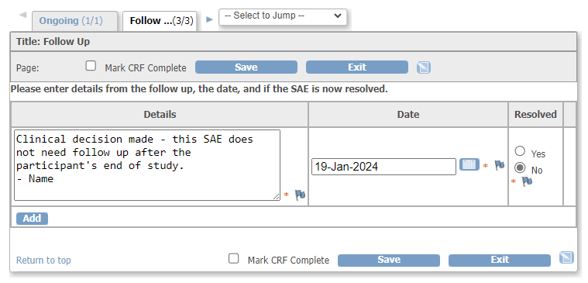

A third tab will open for recording the outcome of the SAE if the ‘resolved’ questions is marked as ‘yes’. Please click on the appropriate radio button for the ‘outcome of SAE’, add a date for the outcome of the SAE and the CRF can then be marked as ‘complete’. Remember to click on ‘Save’.
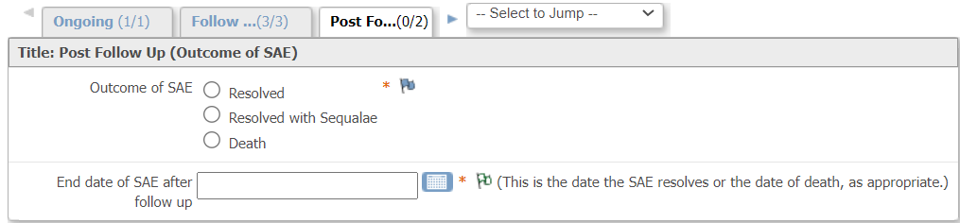

SAE CRF completion – SITE STUDY TEAM
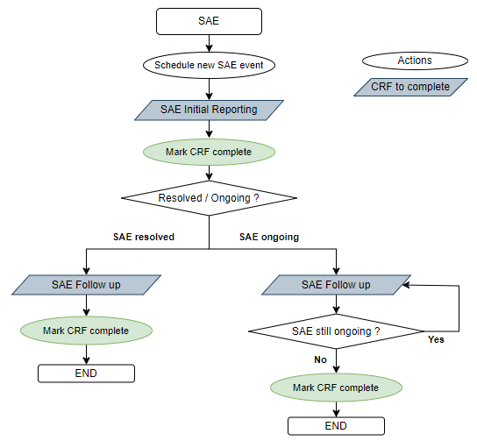
7.0 Marking the CRF as complete
Once all the data has been entered for an event, you will be required to mark the CRF as complete. It is worth ensuring that you have completed all of the required fields in the CRF and any that are not completed have a Discrepancy Note added. On the last tab of the CRFs, there is a tick box next to ‘Mark CRF Complete’. Tick this box if you have fully completed the CRF and there is no further data to enter, then click on ‘Save’. REMEMBER to add a discrepancy note where data is missing or not validated!

When the CRF has been marked as complete the icon for this event will change to completed, otherwise the CRF will remain with a status of ‘Data Entry Started’ . The CRF can still be edited after it has been marked as complete, however you will be prompted to enter a discrepancy note to explain why you are making changes.
Do NOT mark the ConMeds and AEs forms as completed before the end of the study.
8.0 Dealing with data queries
OpenClinica provides users with a way to document and manage queries through the use of Discrepancy Notes in order to verify the accuracy of the data. The previous section 5.0 has explained how you can create a Discrepancy Note, whilst entering data into a CRF, to provide information when a data field is incomplete or has a value that is not as expected. This section provides guidance on data queries raised by the study centre and system generated Discrepancy Notes.
8.1 Queries raised by the study team
When a CRF is marked as complete, the study team will review it. If they have any questions, they will raise a ‘Query’ type Discrepancy Note. Queries will be assigned to a specific user, usually the person who entered the data, and an email notification will be sent. There are a few ways of knowing that you have queries that require an answer, and you should check these on a regular basis.
From the Home screen, check the ‘Notes and Discrepancies Assigned to Me’ underneath the study title. This will show how many you have assigned to you and allow you to access them.
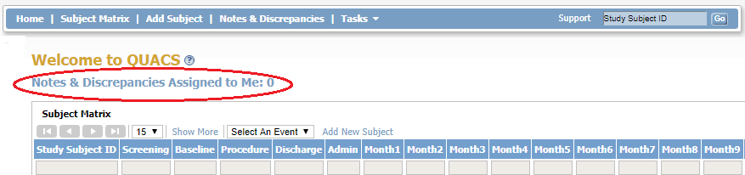
As well as viewing your own Notes & Discrepancies, you can view all Notes & Discrepancies that are assigned to users at your site. Access ‘Notes & Discrepancies’ by clicking on the blue Menu Bar. This opens the Notes & Discrepancies page for all patient CRFs at your site.
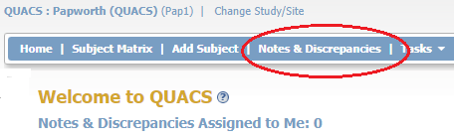
It is possible to filter the results shown within the matrix. Click on the blank box below the blue column heading that you wish to filter by. Type the criteria you want and click on ‘Apply Filter’. You can clear this filter by clicking on ‘Clear Filter’. In the example shown below, the results have been filtered to display only the notes and discrepancies for ‘Subject 004’.
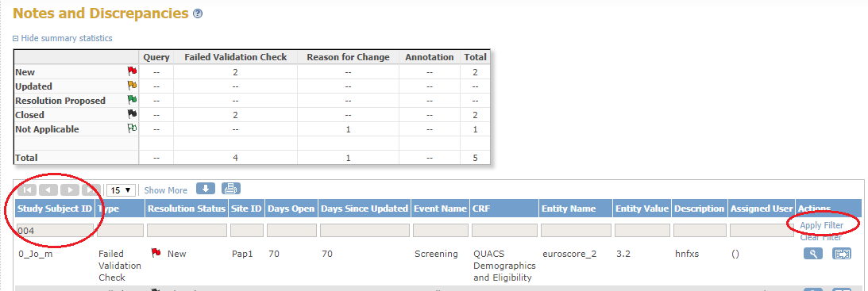
8.2 Responding to queries
Click on the link provided in the Notification Email to access the ‘Notes & Discrepancies’ page.
Or
Click on the red flag icon next to the data field.
Or
Click on ‘Notes & Discrepancies Assigned to Me’ from the Home screen.
Or
Click on the Notes & Discrepancies’ option from the blue Menu Bar. A description of the Query can be viewed in the ‘Description’ column of the Notes & Discrepancies matrix.
To respond to the query:
- Click on the icon at the far right of the row of the Notes & Discrepancies matrix. You will be taken directly to that CRF to resolve the query.
- Make the appropriate amendments to the data based on the information in the query.
- In the Discrepancy Note window, choose the status you are setting the Note to. For example:
- if you are adding more information that needs to be reviewed, click ‘Update Note’
- if you are adding information that will allow the Note to be closed, click ‘Propose Resolution’
- If you are correcting a validated field by overtyping the data, you will also need to add an Annotation Note to confirm your action.
- Click on the ‘Submit’ button to save the information and to keep the window open or click ‘Submit and Exit’ to save the updated information and close the window. If you do not want to save any of the information you provided, click the ‘Exit Window’ link (in the upper right corner).

When responding to queries, please make sure you remember to correct the data field if appropriate, not just respond to the query.

NOTE Only the study team has the ability to close queries i.e. making the flag colour turn to black indicating the query has been closed. Annotations (white flags) are the exception and will remain white as it is not applicable for these notes to be closed.

9.0 Uploading reports
For some studies, the patient consent forms or reports will be uploaded to OpenClinica. You will need to have a clearly scanned image of the document on your PC, and know which folder it is in.
To upload documents or photographs onto the eCRF, click on the ‘Click to upload file’ button (circled below) and follow the instructions in the pop-up box that appears.

10.0 End of Study
This event can be completed by the site or the sponsor when study subjects’ participation in the study finishes: when all parts of the study have been completed, on the death of the patient, if the patient wishes to withdraw from the study or if the patient is a screening failure.
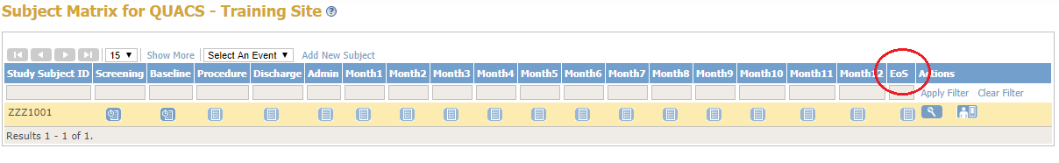
You will be required to manually schedule the event as detailed in the ‘Scheduling an Event’ section above.
Once you have scheduled the event, you will be prompted to select a ‘Reason Trial Completed’ from a drop-down box. If the ‘other’ option is selected, you will be required to enter text into the free text data field stating why the study has ended.
The date of trial completion should be the date participation in the study ended, death or the date the patient withdrew from the study. Remember to tick the ‘Mark CRF Complete’ box and click on ‘Save’.

If you hear of the patient’s death, please enter this information as soon as possible, even if that patient is in follow up.

11.0 Switching studies
You may work on other Papworth sponsored studies that use the OpenClinica platform or you may required access to e-forms, for recording file notes and Protocol non-compliance for your study. To switch from one study to another click on the ‘change study’ button at the top of your screen:
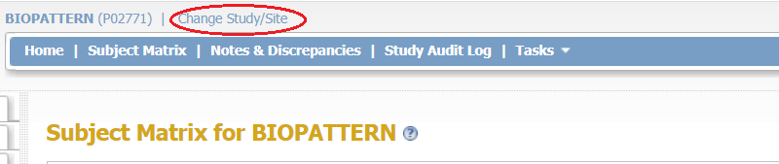

Click on the appropriate radio button for the database you wish to access. Once selected, click on the ‘change study’ button:
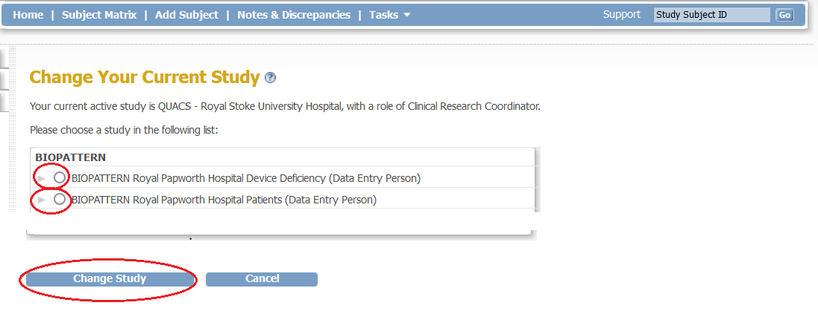
You will be asked to confirm that you wish to change the study; you can do this by clicking on the ‘confirm’ button. You will then be taken to your selected ‘study’ and you will be able to begin work on the study you have selected.

This is the end of the user guide.
Should you have any questions on OpenClinica please contact the Study Team at Papworth.

Document History
Date | Version | Author | Notes
August 2019 | 1.0 (draft) | Simon Lumley | Document rewritten from scratch
August 2019 | 1.1 (draft) | Michelle Austin | Document completion continued
February 2024 | 2.0 | Michelle Austin | Document updated and published
March 2024 | 3.0 | Michelle Austin | ConMeds added, published

